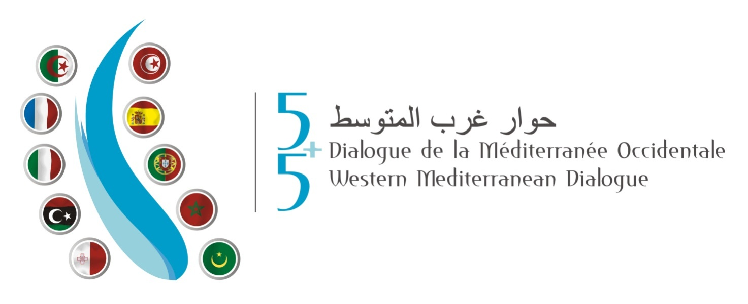

ACTION PLAN FOR THE WATER STRATEGY in the WESTERN MEDITERRANEAN

V10 – Oct. 2016

index
index II
1_ ABSTRACT 3
2_ ACRONYMS 4
3_ Background 6
4_ Scope and Focus 8
5_ Management of the Action Plan 10
5.1 Development 10
5.2 Service Actions 13
Action 1. Monitoring, handling of data and supervision 13
Action 2. Research 17
Action 3. Training and capacity building 19
Action 4. Experience exchange, dissemination and cooperation 22
Action 5. Climate change 27
Action 6. Infrastructure sustainability 30
Action 7. Sustainable aquifer management 32
Action 8. Promoting re-use 34
Action 9. Improvement of the quality of water 37
Action 10. Preservation of aquatic ecosystems 39
5.3 Infrastructure actions 41
Action 11. Infrastructure projects in Libya 41
Action 12. Infrastructure projects in Malta 43
Action 13. Reduction of flood risk in the Júcar River Basin, Spain. 44
5.4 Donors 45
5.5 Dissemination 49
5.6 Monitoring and updating Action Plan 50
 Annex 1: List OF RECEIVED PROJECTS classified by promotEr 51
 Annex 2: Projects’ sheets 58
 Annex 3: Analysis of the projects 59

ABSTRACT
On 31st March 2015, during the first Ministerial Conference on the Water Strategy in the Western Mediterranean (5+5), the Water Strategy in the Western Mediterranean (WSWM), was adopted. The document has the objective of preventing conflicts, fostering development and contributing to ensure the human right to water and sanitation.
This Strategy, promoted by Spain and Algeria, is particularly significant in a region such as the Mediterranean, subject to the adverse effects of climate change and its impacts on population and on economic activities such as tourism, particularly in coastal areas. This Strategy will allow Mediterranean countries to defend a common stance on water management.
The approved Strategy is the result of the consensus of the 10 Mediterranean within the 5+5 Dialogue (France, Italy, Malta, Portugal and Spain on the northern part, and Argeria, Libya, Mauritania, Morocco and Tunisia on the southern part), as well as contributions from the European Commission, the Union for the Mediterranean (UFM) and the Union for the Arab Maghreb (UAM), and the rest of observers.
The present Action Plan will be submitted to the consideration and approval of a Ministerial meeting to be held during the UNFCC COP22 (Marrakesh, Morocco, 7-18 November 2016).
This Action Plan has been developed on the basis of the projects and initiatives submitted by the countries involved, in order to address specific water challenges and help achieve solutions to problems of regional concern with a focus on sustainability. The Action Plan will be annexed to the Strategy. It will promote financing opportunities through well-targeted and sustainable projects according to the criteria established in the Strategy.
The elaboration of the present Action Plan has been possible thanks to the intense engagement of the 10 member countries and of the organisations and observers involved. It has been a very participative process resulting in the set up of the Action Plan itself. A total of 60 projects have been proposed. For the specific materialisation of these projects, 13 actions were defined which include all the presented projects in different groups according to their characteristics. The 13 actions are divided in two main groups, services and infrastructures. This division corresponds to the different features of the projects in regards to objectives, budget, financing and duration. As it could not be otherwise, these 13 actions cover and respond to most of the Strategy’s priorities.
The services group consists of all the projects with the objective of developing analyses, studies, research, training, knowledge transfer and cooperation. The objective of all this is to guarantee the development and implementation of new water policies, whether regional or national, to allow the improvement of governance in regard to water resources management. This group encompasses most of the regional projects. A total of 54 presented projects are included within the 10 actions proposed below, which entail an approximate budget of 144 Million €.
Within the services group, the following actions are defined:
Action 1. Monitoring, data management and supervision
Action 2. Research
Action 3. Training and capacity building
Action 4. Experience exchange, dissemination and cooperation
Action 5. Climate change adaptation
Action 6. Infrastructure sustainability
Action 7. Sustainable aquifer management
Action 8. Fostering water reutilisation
Action 9. Water quality improvement
Action 10. Aquatic ecosystem preservation
The infrastructures group includes projects on construction, viability analyses, etc. Most of the projects covered have a national or local scope. A total of 6 proposed projects are included, which entail a total budget of approximately 279 Million €.
Within the infrastructures group, the following actions are defined:
Action 11. Infrastructure projects in Libya
Action 12. Infrastructure projects in Malta
Action 13. Flood risk reduction in the Júcar River Basin, Spain
Regional projects or national projects that are easily replicable are more interesting according to the Strategy’s criteria.
In order to secure a high degree of success in the development of the Action Plan it is a sine-qua-non condition to obtain the support of the main financial entities be they global, national or regional which may contribute to the development of the project. The search for financing and the implementation of the Action Plan will be the main goal of the follow-up Plan. The search for financing and the implementation of the Action Plan will be the main goal of the follow-up Plan. The funding issue will be addressed at a later stage immediately after the Ministerial endorsement.
In order to pave the way for a better implementation of the Action Plan, a number of activities will be carried out to present and disseminate the Action Plan. The dissemination of the Action Plan is considered of the utmost importance. Thus, a separate document will be created named Dissemination Plan.
The Action Plan will constitute a living document to be enriched by projects that may have either been already implemented, that are being implemented at the moment, or foreseen to be implemented in a short-medium term. As a living document, the implementation of projects included in the Action Plan should be monitored.

ACRONYMS
ACRONYM | NAME
AECID | Agencia Española de Cooperación Internacional para el Desarrollo
AFD | Agence Française de Développement
BAD | African Development Bank Group
BEI | European Investment Bank
BERD | European Bank for Reconstruction and Development
CENTA | Centre for new Water Technologies
CMI | Marseille Centre for Mediterranean Integration
DGRE | Direction Générale des Ressources en Eau (Tunisia)
DREAL | Agence de l’eau Rhône-Méditerranée-Corse
DZ | Algeria
EMWIS | Euro-Mediterranean Information System on know-how in the Water Sector
ES | Spain
EU | European Union
EU | European Union*
FPA2 | Foundation Prince Albert II of Monaco
FR | France
GEF | Global Environment Fund
GWOPA | Global Water Operators’ Partnerships Alliance
GWP-Med | Global Water Partnership Mediterranean
IAMZ-CIHEAM | Mediterranean Agronomic Institute of Zaragoza
IEA | Euro-mediterranean Water Institute
IME | Institut Méditerranéen de l’Eau
IPEMED | Institut de Prospective Économique du Monde Méditerranéen
IT | Italy
IUCN Med | Centre for Mediterranean Cooperation
KFW | KFW Group
LY | Libia
MA | Morocco
MARHP | MINISTERE DE L’AGRICULTUREdes ressources hydrauliques et de la pêche (Tunisia)
MedWet | The Mediterranean Wetlands Initiative
MENBO | Mediterranean Network of Basin Organisations
MIO ECSDE | Mediterranean Information Office for Environment, Culture and Sustainable Development
MR | Mauritania
MT | Malta
MWG 5+5 | Ministerial Water Group of the 5+5 Dialogue
MWO | The Mediterranean Wetlands Observatory
NIF | Neighbour Investment Facility
OECD | The Organisation for Economic Co-operation and Development
OFID | OPEC Fund for International Development
OIEAU | International Office for Water
OPEC | Organization of the Petroleum Exporting Countries
PT | Portugal
RAED | Arab Network for Environment and Development
SEWCU | Sustainable Energy and Water Conservation Unit (Malta)
SIDA | Swedish International Development Cooperation Agency
SWIM | Sustainable Water Integrated Management Program
TAIEX | Technical Assistance and Information Exchange instrument of the European Commission
TDG | Techinical Drafting Group of the 5+5 Dialogue
TN | TUNISIA
UAM | The Union for the Arab Maghreg
UFM | The Union for the Mediterranean
UNDP | United Nations Development Program
UNECE | The United Nations Economic Commission for Europe
UNEP/MAP | Plan Bleu – Environment and Development in the Mediterranean
WB | World Bank
WFN | The Water Footprint Network
WS | Workshop
WSWM | Water Strategy in the Western Mediterranean
WWF MedPO | WWF Mediterranean Program Office
Table nº 1 : List of acronyms

Background
On 31st March 2015, during the first Ministerial Conference on the Water Strategy in the Western Mediterranean (5+5), the Water Strategy in the Western Mediterranean (WSWM), was adopted. The document has the objective of preventing conflicts, fostering development and contributing to ensure the human right to water and sanitation.
This Strategy, promoted by Spain and Algeria, is particularly significant in a region such as the Mediterranean, subject to the adverse effects of climate change and its impacts on population and on economic activities such as tourism, particularly in coastal areas. This Strategy will allow Mediterranean countries to defend a common stance on water management.
The approved Strategy is the result of the consensus of the 10 Mediterranean within the 5+5 Dialogue (France, Italy, Malta, Portugal and Spain on the northern part, and Argeria, Libya, Mauritania, Morocco and Libya on the southern part), as well as contributions from the European Commission, the Union for the Mediterranean (UFM) and the Union for the Arab Maghreb (UAM), and the rest of observers.
The importance of achieving a closer and action-oriented cooperation among the Mediterranean riparian states is reflected in the development and implementation of several regional processes including in the efforts of consolidating the Union for the Mediterranean (UfM). Water and Environment form one of the six priority work areas of the UFM Secretariat. The UfM aims at making substantial contribution to de-polluting the Mediterranean Sea and promoting environmental sustainability.
In that context, the Euro-Mediterranean Ministerial Conference on Water (Dead Sea, Jordan, 22 December 2008) agreed to prepare a shared and long-term Strategy for Water in the Mediterranean and approved guidelines for its elaboration. Despite the fact that there was general consensus from all the countries and experts involved on the technical contents, the references to the main geographical conflicts in the region made it impossible to adopt the Strategy.
For these reasons, the approval of the Water Strategy in the Western Mediterranean (WSWM) has strengthened the re-launching of the Strategy for Water in the Mediterranean that took place in 2016. Therefore, both processes must progress united, with common criteria and creating synergies. This will be possible thanks to the fact that the members of the 5+5 process belong to the Technical Drafting Group (TDG) of the UfM, so the coherence of both processes is guaranteed.
The Strategy is built around three main thematic blocks which underpin 13 priorities
These blocks and priorities that are encompassed into them are the following:
Block 1 : Enhancing Western Mediterranean country policies’ convergence towards the general principles of a sustainable water policy
- Priority 1: Developing and starting up clearly defined legal frameworks
- Priority 2: Establishing governance adapted to integrated water management
- Priority 3: Implementing cost-recovery
Block 2 : Foster cooperation in relation to regional matters
- Priority 4: Capacity building
- Priority 5: Innovation development in the water sector.
- Priority 6: Water-energy-food nexus
- Priority 7: De-pollution of the Mediterranean
- Priority 8: Mobilising water-related innovative financing solutions for the application of the Strategy
Block 3 : Promoting water management improvement
- Priority 9: Climate change adaptation
- Priority 10: Increasing and mobilising the available resources
- Priority 11: Water use efficiency improvement
- Priority 12: Flood prevention
- Priority 13 : Protection of water quality and biodiversity
The idea of the WSWM as a modern document addressing water management issues and priority areas from a Mediterranean perspective, which must be supported with practical projects, was raised.
With the development of these priorities a contribution is made, inter alia, to the promotion of objective 6 “Ensure Access to water and sanitation for all” on sustainable development of the United Nations, approved in September 2015. Among the objectives to be reached it is worth mentioning that a universal and equitable access to drinking water is foreseen to be achieved for 2030 at an affordable price for all, as well as equitable access to adequate sanitation and hygiene services. In addition, it is intended to improve the quality of water, increase the efficient use of resources, put in place the integrated management of resources, protect and restore the ecosystems related to water, increase international cooperation, and reinforce the participation of local communities towards the improvement of water management and sanitation.
In order to implement the Strategy, the current Action Plan is developed which contains the projects and initiatives of the countries involved in order to address specific water challenges and help achieve solutions to problems of regional concern with a focus on sustainability.

Scope and Focus
The Action Plan aims at the successful implementation of the Water Strategy in the Western Mediterranean (WSWM) adopted at the Ministerial Conference on water 5+5 held in Algiers in March 2015. The Action Plan, to be annexed to the WSWM, compiles the proposals submitted by the 5+5 members, regional organisations and observers.
The Action Plan details projects and initiatives with specific objectives, geographical scope, financing plans, foreseen indicators and schedule, allowing to visualise the most pragmatic part of the WSWM.
The Action Plan is the starting point within the Water Strategy dialogue to allow looking for funding to implement the actions included therein. Meetings with the financial institutions will be held in order to show them the Action Plan so that they can identify the most interesting projects to develop depending on their criteria and objectives. The search for financing and the implementation of projects will be the main goal of the Action Plan follow-up.
Moreover, the Action Plan serves as a diagnosis report of best practices and solutions that may be undertaken to address the water issues and work on the priorities reflected in the Strategy. Priority areas such as the use of conventional and non-conventional water resources, water scarcity, water quantity and quality-related aspects, environmental impacts, water protection, water governance, information systems, climate change effects, water-energy-food nexus, research and development opportunities, etc, were identified as areas of interest for practical projects.
The Action Plan should showcase replicable and cross-country-defined national best practices and solutions that imply innovative or technological advances or an outstanding sustainable way of implementing the Strategy. In addition, it highlights the training actions and that on exchange of knowledge. It may also serve as a platform that helps to find partners and mobilise funds for projects.
The Action Plan will promote financing opportunities through well-targeted and sustainable projects according to the following criteria:
- Level of response and contribution to the Strategy’s objectives.
- Level of compliance with and integration to ongoing and/or planned national or regional plans and framework programmes.
- Complementarities with other processes.
- Consistency with IWRM approaches and practices.
- Contribution to achieving water efficiency targets.
- Consistency with environmental protection objectives.
- Contribution to poverty reduction objectives, job creation and education of young people.
- Consideration of social, gender and cultural aspects.
- Level of secured co-financing.
- Economic and financial sustainability.
- Level of foreseen operational synergies, including those with competent stakeholders.
- Projected sustainability of outcomes after completion.
- Possibility of replication.
- Defined geographical scope, either national or regional, within the Western Mediterranean region.
As a result of the above-mentioned considerations, the followed procedure in order to elaborate the Action Plan is defined below together with the description of the Action Plan itself.

Management of the Action Plan

Development
The elaboration of the present Action Plan has been possible thanks to the intense engagement of the 10 member countries and of the organisations and observers involved. It has been a very participative process resulting in the set up of the Action Plan itself. A total of 60 projects have been proposed. The projects received from each participant are listed in Annex 1.
The process started in autumn 2014 where for the first time a form was circulated so that each member could incorporate the most significant and interesting projects to be executed. After the workshops, in particular those held in Madrid in September 2015 (4WS) and in Valencia in February 2016 (5WS), the definition of the projects was progressively fine tuned and the result is a consensus document that serves the objective of implementation of the Strategy.
The Action Plan elaboration was commissioned to the Technical Secretariat of the Ministerial Water Group of the 5+5 Dialogue (MWG 5+5), who received and managed all the information sent by the member countries, regional organisations and observers. This information consists of both the projects themselves presented by each participant and all the comments, observations, worries and suggestions received during the Workshops, and in the communication exchanges. With this information the Action Plan was drafted, with several modifications and additions during the process. The result is a consensus document that contains all the views received.
For the specific materialisation of the Action Plan, 13 actions were defined which include all the presented projects in different groups according to their characteristics.
In order to identify the most suitable and effective tools to address the challenges identified in the Strategy, it is important to highlight the objectives and features of the proposals as follows:
- Proposals should be existing success stories and experiences that have already worked in some countries, easy to replicate in other countries.
- Proposals should have the possibility of extrapolating national projects to the regional scale.
- Projects should foster training, capacity building, research and development programmes, national dialogues, awareness campaigns, etc.
- Proposals should mobilise financing opportunities to develop the Action Plan.
The 13 actions are divided in two main groups, the services group and the infrastructures group. This division corresponds to the different features of the projects in regards to objectives, budget, financing and duration.
The services group consists of all the projects with the objective of developing analyses, studies, research, training, knowledge transfer and cooperation. The objective of all this is to guarantee the development and implementation of new water policies, whether regional or national, to allow the improvement of governance in regard to water resources management. This group encompasses most of the regional projects and their budget is typically low.
The infrastructures group includes projects on construction, viability analyses, etc. Most of the projects covered have a national or local scope and their budget is higher than the above-mentioned “services group” projects.
Regional projects or national projects that are easily replicable are more interesting according to the Strategy’s criteria.
Within the services group, the following Actions are defined:
Action 1. Monitoring, data management and supervision
Action 2. Research
Action 3. Training and capacity building
Action 4. Experience exchange, dissemination and cooperation
Action 5. Climate change adaptation
Action 6. Infrastructure sustainability
Action 7. Sustainable aquifer management
Action 8. Fostering water reutilisation
Action 9. Water quality improvement
Action 10. Aquatic ecosystem preservation
Within the infrastructures group, the following Actions are defined:
Action 11. Infrastructure projects in Libya
Action 12. Infrastructure projects in Malta
Action 13. Flood risk reduction in the Júcar River Basin, Spain
As it could not be otherwise, these 13 actions cover and more or less respond to most of the Strategy’s priorities, even though some should be further reinforced in future updates of the Action Plan. The following table (nº2 y nº3) shows each priority’s development degree within the established Actions. Within each action, the main priorities of the Strategy covered by the projects that form the said action are highlighted in red. Collateral priorities developed by the projects are highlighted in yellow, since most of them respond to several priorities of the Strategy. This table illustrates the link between the WSWM and the Action Plan.
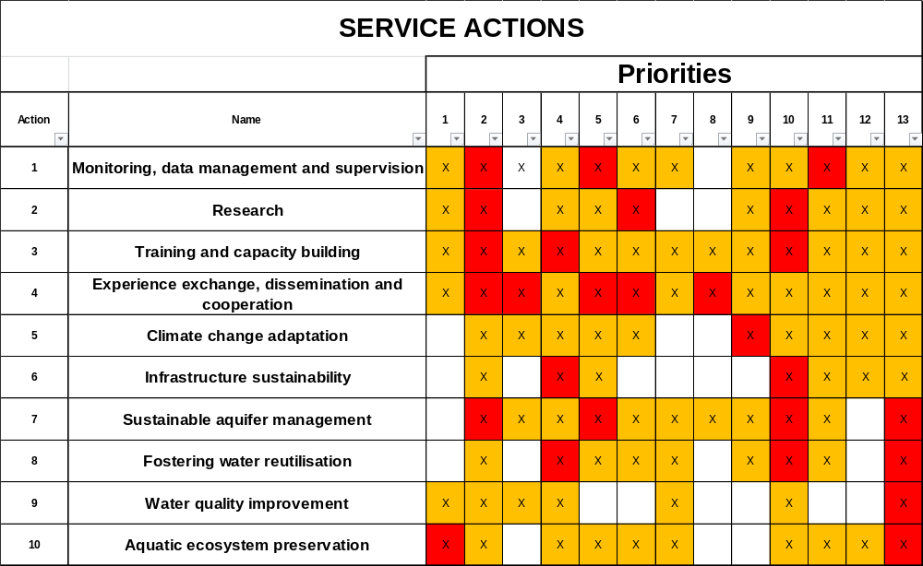
Table nº 2 : Relationship between service actions and priorities developed

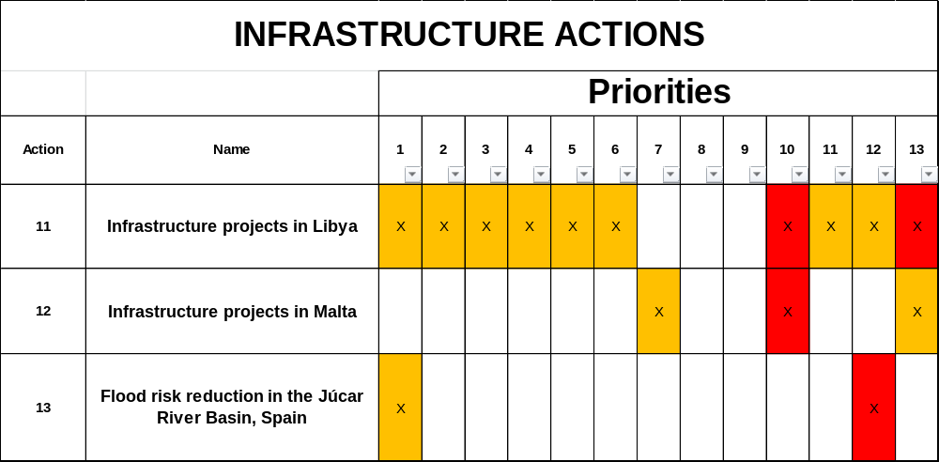
Table nº 3 : Relationship between infrastructure actions and priorities developed

Priority 7 is not developed in the first place, even though can be covered by several actions that improve water quality of discharge to the sea, therefore it will directly improve the water quality in the Mediterranean. Priority 8 is addressed by some projects, but very vaguely.
The implementation of the Action Plan consists of launching and implementing these 13 actions that compile and adopt the 60 projects sent by the 10 member states and by the regional organisations or observers, as well as the contributions received.
Broadly speaking, the total amount of the 60 proposed projects comes to some 423 million EUR, 144 million of which correspond to the 54 services projects proposed (even though 4 of these projects still do not have an assigned budget) and 279 million correspond to the 6 infrastructures projects (even though 1 of these projects still do not have an assigned budget). Approximately 40% of the presented projects have some kind of foreseen funding.
44% of the projects are in a status of “completed design” (CD), “in progress” (IP) or “completed” (C), whereas the remaining 56% have not started yet, are under preliminary status or their state of play is unknown.
All this information is detailed in the specific forms of each project shown in annex 2, where they are classified following the priorities established in the strategy; their objectives, geographical scope, representative indicators, budgets, funds and timelines, are analysed.
Annex 3 develops a quantitative analysis of these projects depending on some of their descriptive variables (geographical scope, priority and thematic block, etc.).
Next, each one of the actions is described.

Service Actions
A total of 54 presented projects are included within the 10 actions proposed below, which entail an approximate budget of 144 Million €.

Action 1. Monitoring, handling of data and supervision
One of the basic premises to achieve an adequate management of water is the knowledge of data, their analysis and updating, as well as their accessibility. This requires that water resources and uses are monitored, collected and stored in databases regularly updated and accessible to the managers.
On the one hand, water resources must be known both in quantitative (appraisals, reservoir levels, piezometric levels, etc.) and in qualitative terms. This requires measurement networks to monitor and supply the necessary data. On the other hand, water uses must also be measured i.e. consumption made by water users (population, environment, agriculture, industry, etc.).
In addition, adequate tools should be available to analyse and handle the data so that they can be reliably used for the management of resources. In the long term, it would be desirable for each country to have National Water Systems that allow them to carry out an integral and transparent water management.
Equally, in order to manage the resources adequately and verify if the design established is respected in reality, it is also important to carry out supervisions of the works and constructions made; hence, any supervision and control task facilitates an adequate management of resources.
Within this action, which is fundamental for the development of all the others, the following 8 projects are encompassed whose features are shown below:
Project No | Title | Promoting country/ entity | Promoter | Geographical scope | Strategy block | Cost (EUR Million) | Term (months)
2 | Central database for water resource in Libya | LY | Information and Documentation Centre (Ministry) | National | 1 | 1 | 36
3 | Monitoring the use of water resources in Morocco | MA | Moroccan delegate Ministry in charge of Water | Regional | 1 | 4 | 72
4 | Environmental Performance Review (EPR) of the Kingdom of Morocco | MA/UNECE | PPA (Portuguese Water Partnership) | National | 1 |  | 8
23 | Use of innovative technologies and approaches for the monitoring of the water resources of Grombalia region | TN | Water research and technologies centre | National | 2 | 1,025 | 48
38 | Executive Information System for the governance and management of Water Resources in the Western Mediterranean | IT | MATTM | Regional Western Mediterranean Area | 1 | 2 | 36
43 | Water use monitoring of Irrigated agriculture in ES by earth observation WATER-EO | ES | University of Castilla La Mancha and Ministry | National | 3 | 0,5 | 28
44 | Studies and projects for the irrigation project of Gharb | MA¹ | COBA (PT) | Local | 3
45 | Supervise irrigation works in Morocco | MA¹ | Aqualogus (PT) | Local | 3
Table nº 4 : Projects incluided in Action 1: Monitoring, handling of data and supervision
All the projects, except the one promoted by Italy, have a national scope and could be divided between those intending to monitor resources and those monitoring uses. These are projects proposed by southern countries except for Spain and Italy. With the project from Spain it is intended to control agriculture uses by applying Earth Observation, EO, and web based Geographic Information System, web GIS, technologies, with the aim to improve efficiencies. In turn, the project of Italy aims to gather all relevant data regarding river basin management planning in a single depository and bridge an information gap hindering effective management decisions. Three of the projects are developed in Morocco but have been proposed to the Action Plan by Portugal. These are projects that do not focus on monitoring but rather on the supervision of irrigation works, management of resources and integration of environmental and socioeconomic policies. Portuguese companies have participated in all the three projects be it as awarded companies or as having participated it their development.
Through the development of this action, the following priorities of the Strategy are mainly fostered among others:
Priority 2 “Establishing governance adapted to integrated water management”. Through the elaboration of the projects proposed, the first phase necessary for a correct management of water is achieved, as without the correct data from the start, management would be faulty.
Priority 5 “Innovation development in the water section”. This priority is mainly represented in the project proposed by Tunisia with which it is intended to develop innovative technologies in the monitoring of water resources.
As we find ourselves in a 5+5 process where communication and dissemination are fundamental, the successes and innovations achieved will be shared with the rest of the member countries, making the project a replicable one.
Priority 11 “Water use efficiency improvement”. Through the monitoring of water uses and in particular in the agriculture field, as intended in the proposed projects, the real consumption of this demand will be controlled. This will allow to improve the efficiency of water uses since, without the correct data from the start it is very difficult to achieve an adequate management of resources.
The total budget of this Action would be 8,525 Million €, distributed among the projects as shown in the following graph:
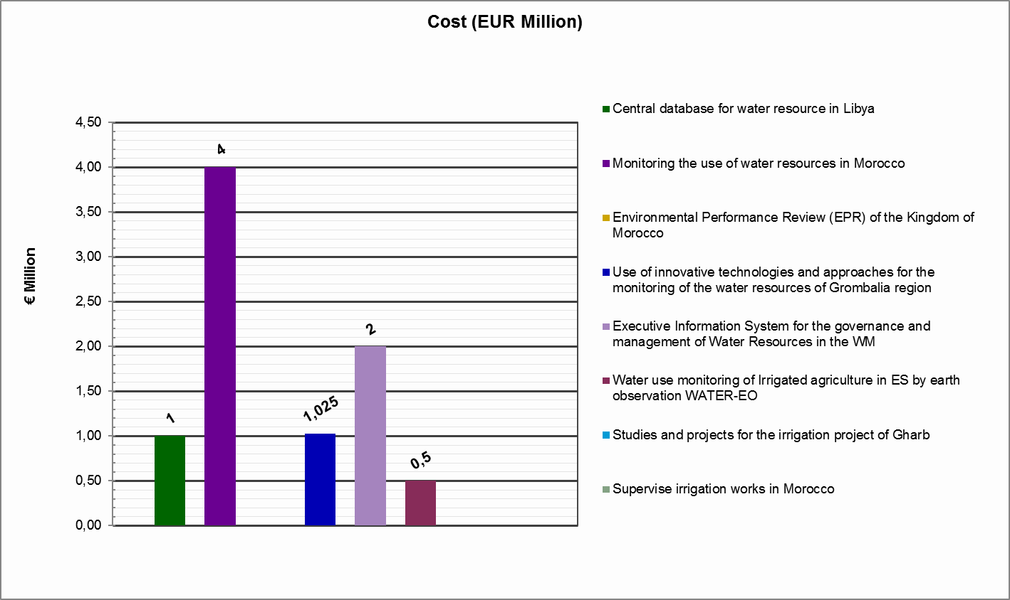
Figure 1 : Budgets for the projects incluided in Action 1: Monitoring, handling of data and supervision
The timeline for implementation is very varied and ranges from 8 to 72 months.
On a valued chronogram, this Action would look as follows:
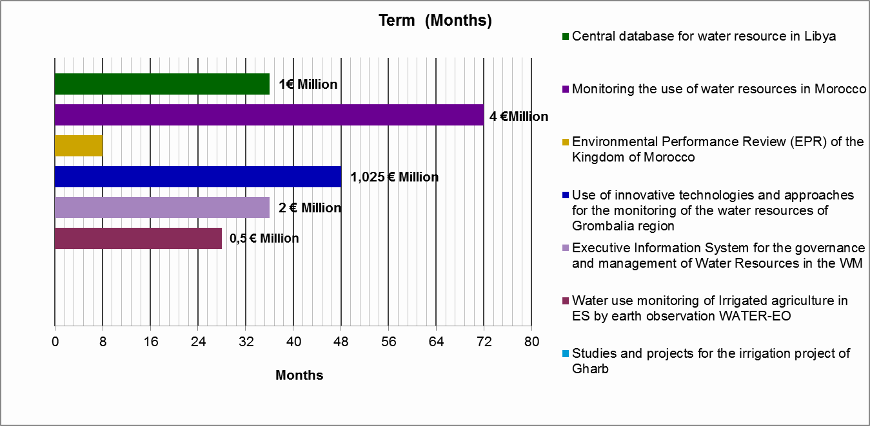
Figure 2 : Timeline for the implementation of the projects included in Action 1: Monitoring, handling of data and supervision

Action 2. Research
Before the training, capacity building of technicians and exchange of information, but after the monitoring and data collection, research and development works are needed, allowing to obtain new knowledge and its application to problem solving.
On the one hand, research in the water sector has been going on for a long time and a more adequate and sustainable management is increasingly being carried out. Yet, on the other hand new challenges and technologies appear which oblige to continue carrying out research in a number of fields.
Among the new themes to investigate, two of them appear in the projects presented by Tunisia and Morocco that are encompassed within this Action.
These new themes are the use of desalination through technologies aiming to reduce the costs and impacts of climate change as well as to rain harvesting in urban areas, with the dual purpose to increase available resources and to avoid flooding in urban areas.
Project No | Title | Promoting country/ entity | Promoter | Geographical scope | Strategy block | Cost (EUR Million) | Term (months)
24 | Seawater desalination by using renewable energy | MA | Moroccan delegate Ministry in charge of Water | Regional | 2 | 16,5 | 120
37 | Water harvesting systems in urban areas | TN | Ministry of Agriculture | National (100 water harvesting systems) | 3 | 10 | 60
53 | A cross-cutting study on a dynamic analysis of the coherence between national policies and the Water Strategy in the Western Mediterranean | MENBO | Technical Secretariat of the MGW 5+5 (MENBO) | Regional | 1 | 0,8 | 24
Table nº 5 : Projects included in Action 2: Research
Rain harvesting in urban areas is in line and responds to priority 10 of the Strategy as it promotes a source of water rarely used so far while, at the same time, attracting increasing interest as stated during the workshops held. This is a line to be developed in this first Action Plan where the project promoted by Tunisia could serve as a good basis for future proposals while conferring the extrapolation character of the process.
Regarding the project about desalination by using renewable energy, it is very important to deepen into the issue as desalination is an available resource that is not affected by temporal variability and that can help managing the demand of water. Most countries involved in the process, have a high level of experience in desalination; but the use of renewable resources that could save management costs, should be fostered. This project would develop priority 6 “Water-energy-food nexus” since it would allow to increase the water available for human consumption or for agriculture at a more reasonable cost that using other types of energies.
Addition, a very interesting project has been included in this Action, about a cross-cutting study on a dynamic analysis of the coherence between national policies and the Water Strategy in the Western Mediterranean. This project will be promoted by the MENBO Secretariat and it will allow analysing the coherence between the policies of all the countries members of the 5+5 with the WSWM. As any research project, this Action requires long periods for implementation (between 24 and 120 months) and high budgets since they involve pilot projects that drive up the costs.
The total budget of this Action would be 27.3 Million €, distributed as follows:
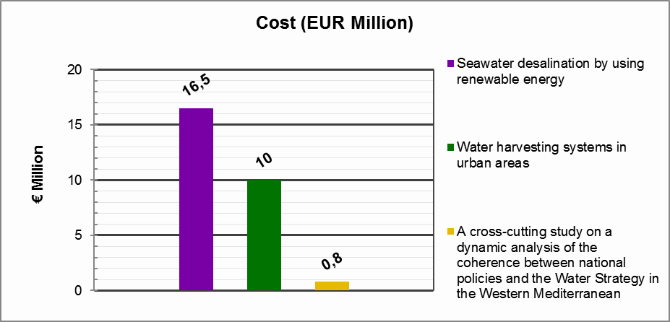
Figure 3 : Budgets for the projects included in Action 2: Research
On a valued chronogram, this Action would look as follows:
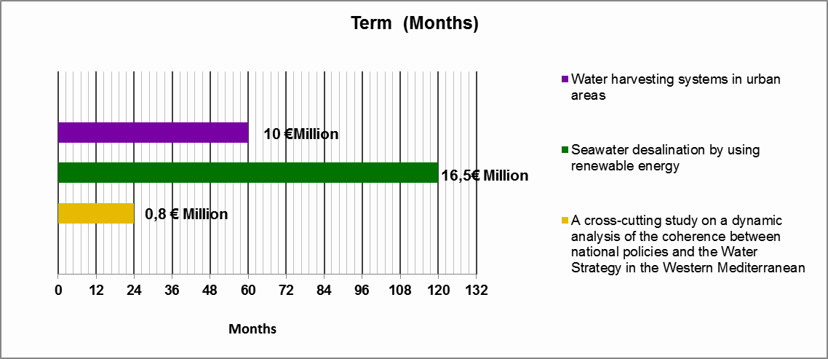
Figure 4 : Timelines for the implementation of the projects included in Action 2: Research

Action 3. Training and capacity building
In order to achieve a sustainable and integrated management of water, decision making should take into consideration every stand point while harmonising the satisfaction of demand with the environmental objectives and the social and territorial balances. To achieve that, the technicians responsible for the management should be capable and well trained in all aspects related to management according to the characteristics inherent to each country.
In this regard, it is important to make the most of one of the advantages of this process namely the participation of 10 countries and organisations with different degrees of experience in the key subjects. This fact allows us to have the support of the most experienced countries and technicians who can help with the training of technicians from less experienced countries that so require to help develop their policies.
Therefore, the following Action is elaborated with the objective of organising the training of the stakeholders involved in water management in the more demanded tasks and with less information. This Action is in line and responds fully to priority 4 “capacity building” whose aim is to improve the knowledge and training of technicians.
The projects included in this Action are the following:
Project | Title | Promoting country/ entity | Promoter | Geographical scope | Strategy block | Cost (EUR Million) | Term (months)
5 | Renforcer la gouvernance du secteur de l'hydraulique en milieu rurale et semi urbain mauritanien | MR | Ministère de l'hydraulique et de l'Assainissement | National | 1 | 1,2 | 36
16 | Training and capacity building in governance and the water resources management | ES | IEA Foundation University of Murcia | Regional  Mediterranean Basin | 2 | 0,1 | 1
17 | Renforcer les capacités des acteurs du secteur de l'eau en Mauritanie | MR | Ministère de l'hydraulique et de l'Assainissement | National | 2 | 0,7 | 24
20 | Renforcement des capacités de gouvernance des ressources en eau | DZ | Ministère Algérien des Ressources en Eau et de l'Environnement | Regional | 2 | 0,3 | 24
30 | REUSE-Professionalizing the water REUSE to tackle water issues in the western Mediterranean | FR | Ecofile | Regional  Western Mediterranean countries (short time) | 3 | 1,1 | 36
54 | Training actions to support the implementation of projects that develop the priorities of the WSWM | IAMZ-CIHEAM | IAMZ-CIHEAM | Regional. Western Mediterranean | 2 | 0,1 | 12
Table nº 6 : Project included in Action 3: Training and capacity building
Four of the six projects included are of a regional scope. As for the remaining two, although they have a national scope, they require the participation of technicians from other countries that take part in the training. The projects included in this Action are the most cost-effective while their consequences are very valuable.
Apart from the development of priority 4 mentioned above, in-depth attention is paid to priority 2 “Establishing governance adapted to integrated water management” since the training of water managers in different areas of action is reinforced, as for instance in rural areas in the same way as proposed in the project from Mauritania intending to enhance the capacity in management aspects, planning, quality control, role of the state, etc. In addition, priority 10 “Increasing and mobilising the available resources” is also developed through the project promoted by Ecofile (FR) on the professionalisation of water reuse in the Western Mediterranean. This project will also create synergies with the projects presented within Action 9 regarding the promotion of reuse.
Within this action, a project proposed and co-financed by the Mediterranean Agronomic Institute of Zaragoza (IAMZ-CIHEAM) is included; this project will intend to address the training needs that may arise during the implementation of the projects of the Action Plan, defining the necessary courses and adapting to the needs of the project. It is foreseen to organise two or three course per year.
The total budget of this Action is 3.5 Million €, distributed as follows:
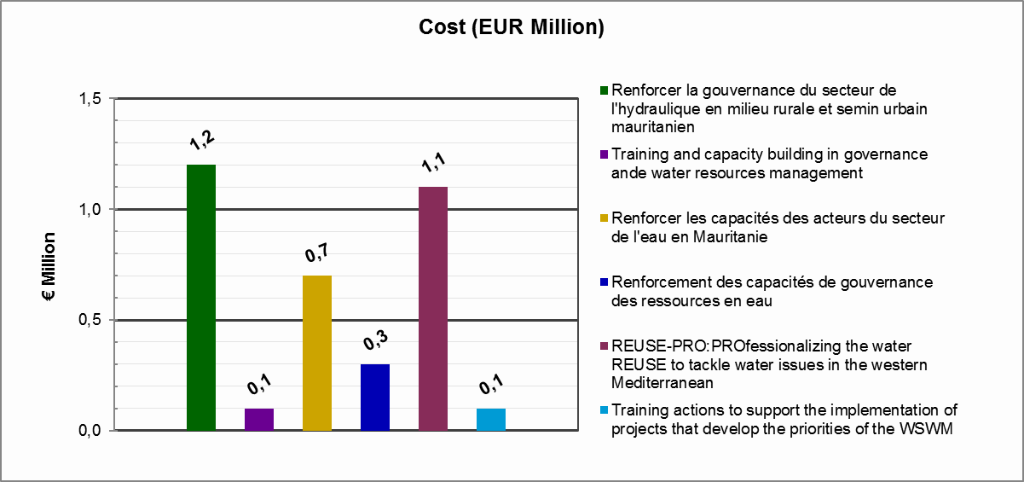
Figure 5 : Budgets for the projects included in Action 3: Training and capacity building
It can be said that the implementation periods are short, ranging from 1 month up to 36.
On a valued chronogram, this Action would look as follows:
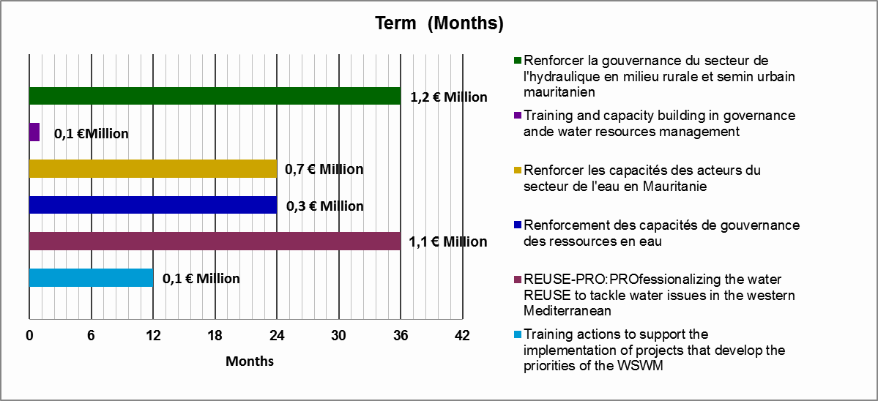
Figure 6 : Timelines for the implementation of the projects included in Action 3: Training and capacity building

Action 4. Experience exchange, dissemination and cooperation
Experience and information exchange between technicians from different countries and organisations, expert in water resources management, is an important pillar to improve management in each country. The results of research and capacity building developed by each one can be shared with other technicians, thus creating synergies and avoiding using human and economic resources to study topics already analysed elsewhere.
On the other hand, to achieve an integrated and sustainable water policy, cooperation and communication amongst those involved in the process, namely water managers and all the other stakeholders (civil society, operators, etc.), is necessary. In this sense, it is important to foster international cooperation, particularly amongst countries sharing resources, in order to harmonise water uses to benefit the countries involved, while protecting water resources.
This Action intends to foster experience exchange, knowledge dissemination and cooperation amongst stakeholders, as well as looking for synergies.
It includes the creation of common repositories where information can be exchanged on specific topics in order to make available the details on progress already made by other members and to avoid duplicities.
To achieve these objectives it is necessary to disseminate information, and in this sense, the 5+5 process is the ideal forum. This Action Plan also has a Dissemination Plan where all the relevant information on the different proposed actions will be updated.
The projects included in this Action are the following:
Project Nº. | Title | Promoting country/ entity | Promoter | Geographical scope | Strategy block | Cost (EUR Million) | Term (months)
7 | Water Convention: global framework for transboundary water cooperation | UNECE | UNECE, Global Water Partnership Mediterranean, UfM | Regional  Western Mediterranean region (and beyond) | 1 | 0,9 | 24
8 | Innovative hydro-economic modelling as leverage to reduce pressure on water stressed basins in the Western Mediterranean | IT | Ministero dell’ambiente | Regional (2-3 pilot areas) | 1 | 1,2 (estimated) | 36
9 | Governance & financing for the Mediterranean Water Sector | GWP-Med+OECD | GWP-Med+OECD | Regional  Mediterranean region with focus on Albania, Egypt, Jordan, Lebanon, Morocco, Palestine, and Tunisia | 1 | 1,34 | 36
10 | Full application of FCR principle and PPP | IT | Ministero dell’ambiente | National (7 River basin districts) | 1 | 2 | 72
11 | Sustainable Water Integrated Management (SWIM) Programme – phase II | EU | EU | Regional  Morocco, Algeria, Tunisia, Libya, Egypt, Palestine, Jordan, Israel, Lebanon, Syria(?) | 2 | 15 | 48
12 | Mediterranean Water Knowledge Platform | IOW / IME | IOW / IME | Regional  Regional project with national implementations (4 south Med countries, 2 of them in the Western area, Morocco and Tunisia) | 2 | 5 | 24
13 | 5+5 Water Operators´ Partnership Platform | GWOPA | GWOPA | Regional  5+5 countries | 2 | 2,5 | 36
14 | BlueGreen- Networking civil society in the Mediterranean Region | IME/IUCN/ MIO-ECSDE/ RAED / WWF | IME/IUCN/ MIO-ECSDE/ RAED / WWF | Regional  Regional project with national implementations; 3 of the target countries are from the western Mediterranean (Algeria, Morocco, Tunisia) | 2 | 1,98 | 36
15 | Establishment of a Water Scarcity and Drought assessment platform | MT | SEWCU | National | 2 | 0,15 | 36
34 | A new approach for multi-stakeholder engagement: the Water Living Lab network | PT | ISA-ULisbon (PT), CENTA (ES) and OIEAU (F) association | Regional. All Mediterranean countries, from north and south | 2 | 4 | 24
35 | Towards sustainable intensification in agriculture | PT | University of Lisbon/ School of Agriculture (ISA) | Regional. All Mediterranean countries | 2 | 5 | 24
46 | National Water Conservation Campaign | MT | SEWCU | National | 3 | 10 | 48
57 | Integrated Water Resources Management and Governance in Morocco | EU/MA | EU/MA | National | 2 | 1,15 | 24
58 | Governance and water resources integrated management in Algeria | EU/ALG | EU/ALG | National | 2 | 1 | 24
59 | Implementation and Management of Innovative Funding Mechanisms to ensure access to water and sanitation in the Mediterranean | IPEMED | IPEMED (Institut de Prospective Économique du Monde Méditerranéen) | Regional | 2 | 0,1 | 12
Table nº 7 : Projects included in Action 4: Experience exchange, dissemination and cooperation

This Action encompasses almost all the projects proposed by regional organisations and the priorities developed would be numerous since it is a cross-cutting Action in regard to all the topics.
On the one hand, the Mediterranean Water Institute and the International Office for Water propose to create a water platform to exchange data, knowledge, experiences, etc. (Project 12. Mediterranean Water Knowledge Platform). This platform would make all the information available and would allow evaluating the best practices on identified topics, as well as carrying out a follow-up of the policies and projects developed in each country. The project budget is 16 Million € for the whole Mediterranean divided into two phases, 10 million € for the first phase (24 months) and 6 million € for the second phase (24 months). From this budget, approximately 50% correspond to 5+5 countries. Therefore, this first Action Plan includes a 24 month project (1st phase) and a budget of 5 million €.
This platform could be the common repository for exchange information on all the projects. EMWIS has also offered to host all the 5+5 project information in its website.
The project proposed by Portugal is also developed in the same line (Project 34. A new approach for multi-stakeholder engagement: the Water Living Lab network) and proposes the creation of a Water Living Lab network in order to integrate the research and innovation processes within a public-private-people partnership. Portugal also proposes a project (Project 35 Towards sustainable intensification in agriculture), aiming at providing innovative experiences in the field of sustainable intensification regarding water resources, management, and fertilizer consumption in agriculture.
On the other hand, the SWIM Project (Project 11. Sustainable Water Integrated Management (SWIM) Programme – phase II) promoted by the EU could contribute to the development of the proposed projects by including them in the available funds, thus offering support mechanisms to the countries in order to improve water governability. Moreover, the results of the pilot projects could provide experience for the rest of the countries to test new approaches and technologies that can be replicated elsewhere. It is a project with a high budget of 15 million € for 48 months, but its geographical scope is wider than the 5+5. Another reason for its high budget is that it includes pilot projects.
As mentioned above, cooperation between countries sharing resources (transboundary cooperation) is very important to guarantee an integrated basin management. In this sense, there is a project promoted by UNECE (Project 7.Water Convention: global framework for transboundary water cooperation) that works on this subject trying to create mechanisms to strengthen international cooperation and creating an intergovernmental support platform.
An important topic on which there should be more information exchange and consensus is the economic issues in respect of water management. It should be more present in future updates of the Action Plan. This first Plan covers the views offered, which focus on the implementation of the cost-recovery principle for water services and the “polluter pays” principle. There is a regional project promoted by GWP-Med and OECD (Project 9. Governance & financing for the Mediterranean Water Sector) that could meet these expectations, and an Italian project to be implemented in 7 river basins (Project 10. Full application of FCR principle and PPP). These projects could be the embryo for future projects to be included in the next updates of the Plan, therefore one of the results of the regional project by GWP-Med and OECD should be to identify the needs to cover on these issues in the Western Mediterranean scope. Reinforcing the previous issues and extending the knowledge on economic issues, appears Project 59 “Implementation and Management of Innovative Funding Mechanisms to ensure access to water and sanitation in the Mediterranean”, which aims at deepening into the financing mechanisms of water and at achieving a sustainable system of cost recovery. This project is the only one developing priority 8 “Mobilising water-related innovative financing solutions for the application of the Strategy” of the Strategy, but in future updates of the plan, more emphasis should be given to this priority that has had little interest so far.
Last, another interesting subject for the members is the information exchange and dissemination on water scarcity and droughts. Three national projects that deal with this topic are included: Project 8. Innovative hydro-economic modelling as leverage to reduce pressure on water stressed basins in the Western Mediterranean (IT), Project 15. Establishment of a Water Scarcity and Drought assessment platform (MT) and Project 46. National Water Conservation Campaign (MT).
The total budget of this Action would be 51,32 Million €, distributed as follows:
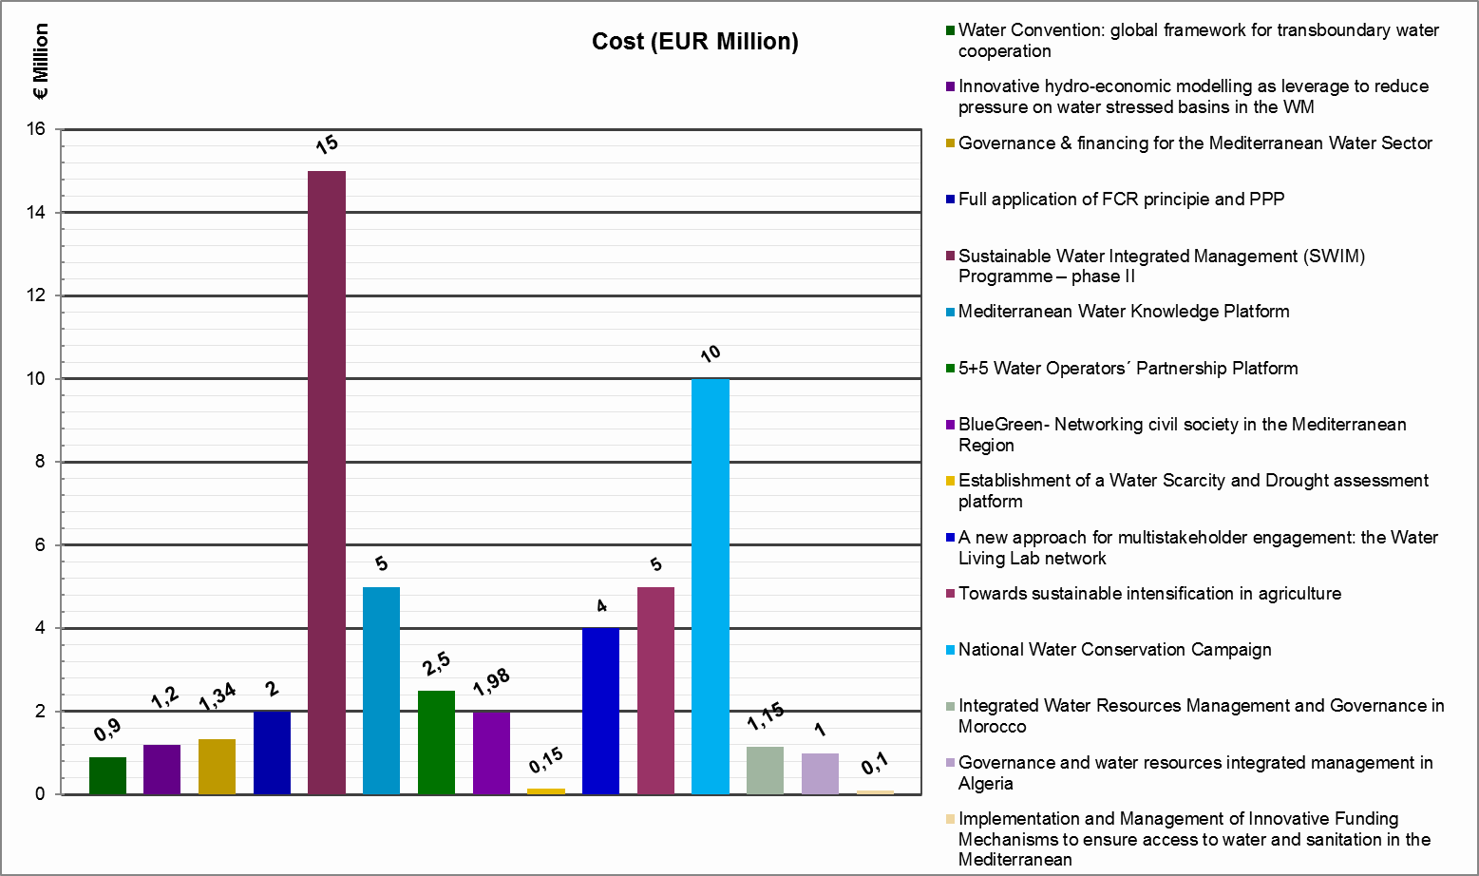
Figure 7 : Budjets for the projects included in Action 4: Experience exchange, dissemination and cooperation

The timelines for implementation are very varied, ranging from 12 to 72 months.
On a valued chronogram, this Action would look as follows:
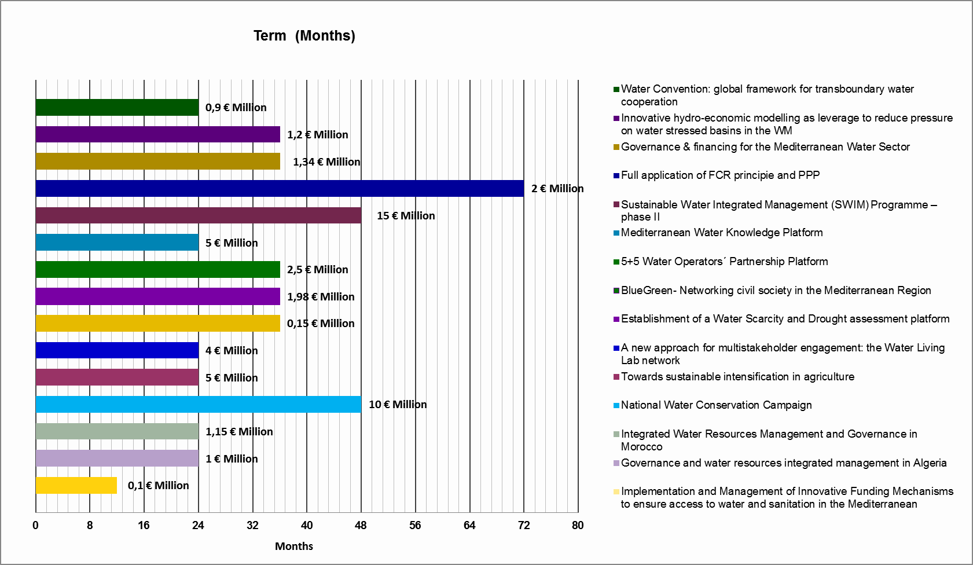
Figure 8 : Timeline for the implementation of the projects included in Action 4: Experience exchange, dissemination and cooperation

Action 5. Climate change
Impacts of climate change on the Mediterranean region, and particularly on vulnerable countries, have been identified as a major climate change hotspot and challenge. The impacts produced by climate change can be aggravated when occurring in regions that already present low water resources levels and frequent droughts, and, hence, imbalances between water demands and available resources. The Western Mediterranean is very vulnerable to climate changes due to the high spatial and temporal irregularity of water resources, the elevated degree of water use and linked socio-economic impacts, in addition to its location in an area projected to have temperature increases and precipitation decreases.
The Action aims at analysing climate change effects in the Western Mediterranean and developing adaptation measures, thus covering priority 9 “Climate change adaption” of the Strategy, which focuses on the same objectives.
In order to address this priority, there are two regional projects, leaded by Algeria and MENBO, whose objective is to analyse climate change consequences and adaptation in the Western Mediterranean. The results and results from these projects could be contrasted with those obtained in a similar project leaded by France in the Mediterranean basin of Rhône, whose objective is to define actions according to the area vulnerability, obtained from maps.
Moreover, a new view is stated in this Action Plan on climate change and mitigation actions in urban areas, which could be addressed with the development of the project promoted by Italy that focuses on urban drainage systems. This topic is less popular than the previous one, but very important. Also, even though the project has a national scope, it can easily be extrapolated.
The mentioned projects and their main characteristics are the following:
Project Nº. | Title | Promoting country/ entity | Promoter | Geographical scope | Strategy block | Cost (EUR Million) | Term (months)
25 | Hydrological consequences of climate change in W.MED. | MENBO | MENBO | Regional  Basins of various countries flowing into the Mediterranean (France, Spain, Morocco, Algeria) | 3 | 1,8 | 24
26 | Plan bassin d’adaptation au changement climatique Rhône-Méditerranée | FR | "DREAL  Agence de l’eau Rhône-Méditerranée-Corse | National | 3 | 0,4 | 72
27 | Adaptation aux conséquences des changements climatiques | DZ | Ministère Algérien des Ressources en Eau et de l'Environnement | Regional (Les pays Méditerranéens) | 3 | 3 | 36
28 | Climate change mitigation Action in urban areas in the Western Mediterranean | IT | Ministero dell’ambiente | Regional | 3 | 5 | 72
Table nº 8 : Projets included in Action 5: Climate change
The total budget of this Action is 10,2 Million €, distributed as follows:
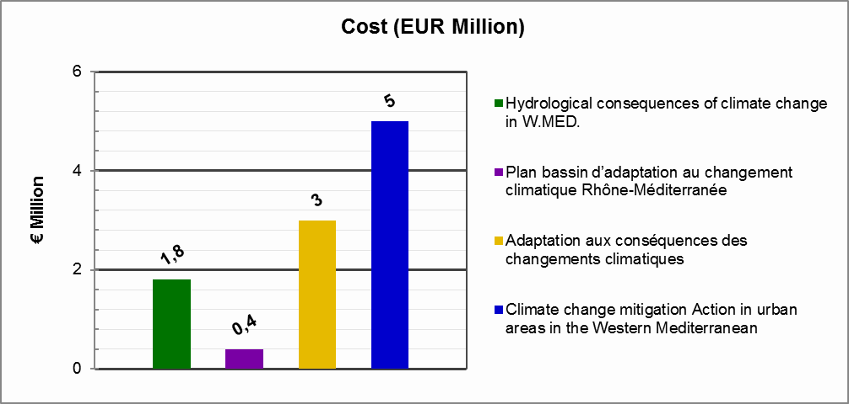
Figure 9 : Budgets for the projects included in Action 5: Climate change
The timelines for implementation are very varied, ranging from 24 to 72 months.
On a valued chronogram, this Action would look as follows:
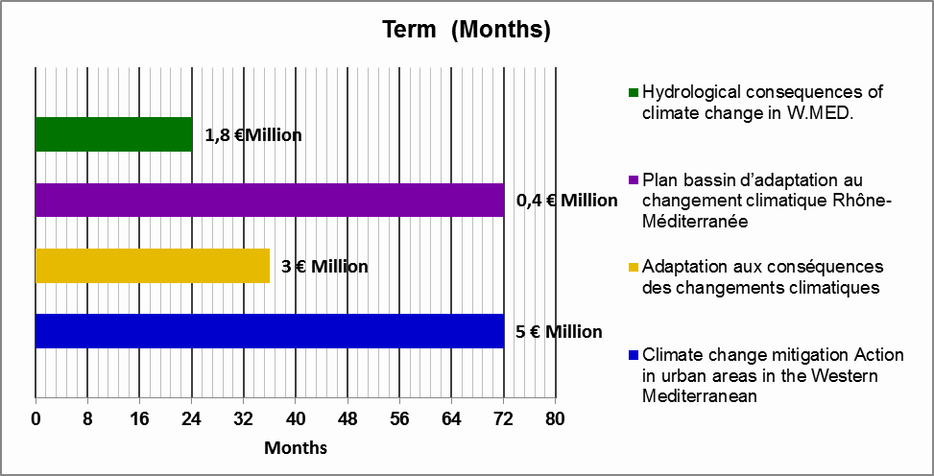
Figure 10 : Timeline for the implementation of the projects included in Action 5: Climate change

Action 6. Infrastructure sustainability
When designing a project of any infrastructure, not only technical aspects for its construction and functioning must be considered, but also environmental, social and economic aspects that might condition or improve the design. Moreover, it is necessary to bear in mind all the phases of the infrastructure’s life (construction, functioning, maintenance and demolition or abandonment) and evaluate each one of them. For this reason, the variables to consider in the design of any infrastructure must be wider than usual and require special attention.
The projects included in this Action respond mainly to three priorities of the Strategy, priority 10 “Increasing and mobilising the available resources”, priority 11 “Water use efficiency improvement” and priority 4 “Capacity building”, since an appropriate and sustainable design of the infrastructures means the mobilisation and increase of available resources as well as an increase of the uses efficiency, as it accounts for all aspects related to the usable life of the infrastructure.
Even though within this action any type of infrastructure can be included, dams present the most relevance and interest. In fact, dams where the main topic of a thematic session of Workshop 5 held in Valencia. It is a very interesting subject and very popular in the southern countries, not only in regards to construction but also in relation with solving the problems associated to dams (sedimentation, floods, etc.). Dam sediment elimination has been mentioned by Tunisia during the workshops, and supported by other countries that need information on previous experiences from other countries to face these problems. Even though the project has a national scope, it can be easily extrapolated to other scopes.
The northern Mediterranean countries have vast experience in this respect and many well-known technicians could assist and support technicians from interested countries.
Most of the presented projects belong to the infrastructures group, but there are three projects that have had much interest during the workshops, and it might be interesting to develop them within the services group.
Project Nº. | Title | Promoting country/ entity | Promoter | Geographical scope | Strategy block | Cost (EUR Million) | Term (months)
19 | Sustainability (environmental, economic and social) of dams in the Western Mediterranean | ES | Spain | Regional | 2 | 0.8 | 24
40 | Dévasement du Barrage El Kébir | TN | Ministry of Agriculture | Local | 3 | 0.815 | 48
39 | Création d’un Barrage sur Oued El Htab et création d’un projet de développement intégré dans son Bassin Versant | TN | Ministry of Agriculture | National( center ouest) | 3 | 0.5 | 24
Table nº 9 : Projets included in Ation 6: Infrastructure sustainability
The total budget of this action is 2.11 Million €, distributed as follows:
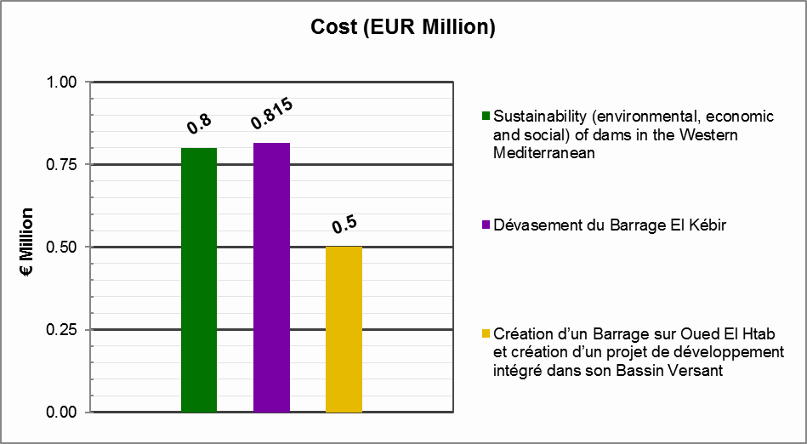
Figure 11 : Bugets for theprojects included in Action 6: Infrastructure sustainability
The timelines for implementation range from 24 to 48 months.
On a valued chronogram, this Action would look as follows:
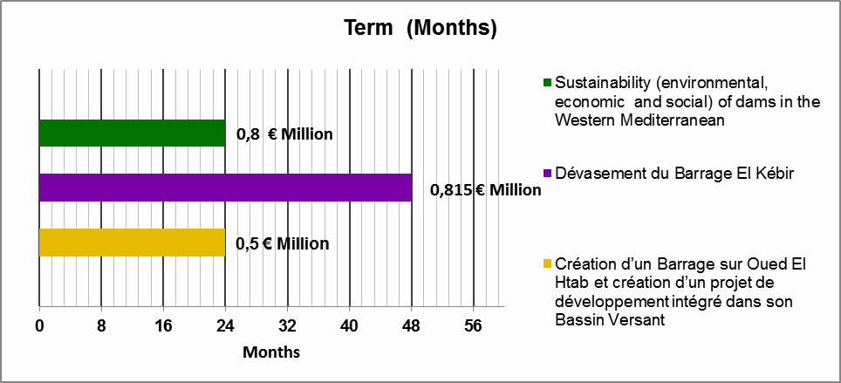
Figure 12 : Timeline for the implementation of the projects included in Action 6: Infrastructure sustainability

Action 7. Sustainable aquifer management
Groundwater is a very important resource with great advantages in respect of surface water, but it is difficult to manage. Further attention on the key aspects of their management is one of the objectives of the Action Plan, as stated by several members, especially in regards to aquifer recharge to obtain an increase of available resources and sustainable management, in order to avoid the frequent overexploitation of aquifers.
Projects included in this Action focus mainly on four priorities of the Strategy, priority 2 “Establishing governance adapted to integrated water management”, priority 5 “Innovation development in the water sector”, priority 10 “Increasing and mobilising the available resources” and priority 11 “Protection of water quality and biodiversity”. With the sustainable management of aquifers an increase of available resources and an improvement of water quality can be achieved, but it is necessary to find solutions that are environmentally sustainable, technically viable and socially desirable. All innovation applied to aquifer management will contribute to improving the water sector.
The projects included in this Action are the following:
Project Nº. | Title | Promoting country/ entity | Promoter | Geographical scope | Strategy block | Cost (EUR Million) | Term (months)
6 | Sustainable aquifer management of the high Guadiana | ES | Spain | Local | 1 | 10 | 72
22 | Managed Aquifer Recharge Schemes | MT | SEWCU  WSC | National | 2 | 5 | 48
41 | Recharge artificielle de la nappe d'El Fahs par les eaux usées traitées | TN | MARHP : Direction Générale des Ressources en Eau "DGRE" | National (Nord de la Tunisie) | 3 | 0,8 | 24
42 | Recharge artificielle de la nappe d'oued Essmar_Mednine par les eaux usées traitées | TN | MARHP : Direction Générale des Ressources en Eau "DGRE" | National (Sud-Est de la Tunisie) | 3 | 0,9 | 24
Table nº 10 : Projects included in Action 7: Sustainable aquifer management
Most of them address the artificial recharge of aquifers, where it is indispensable to reach a balance between the water abstractions and the recharge capacity of the aquifer. Also, the possibility of salinisation of aquifers must be considered due to excessive pumping. All projects have a national scope and could be pilot projects to be extrapolated elsewhere.
The total budget of this Action is 16,7 Million €, distributed as follows:
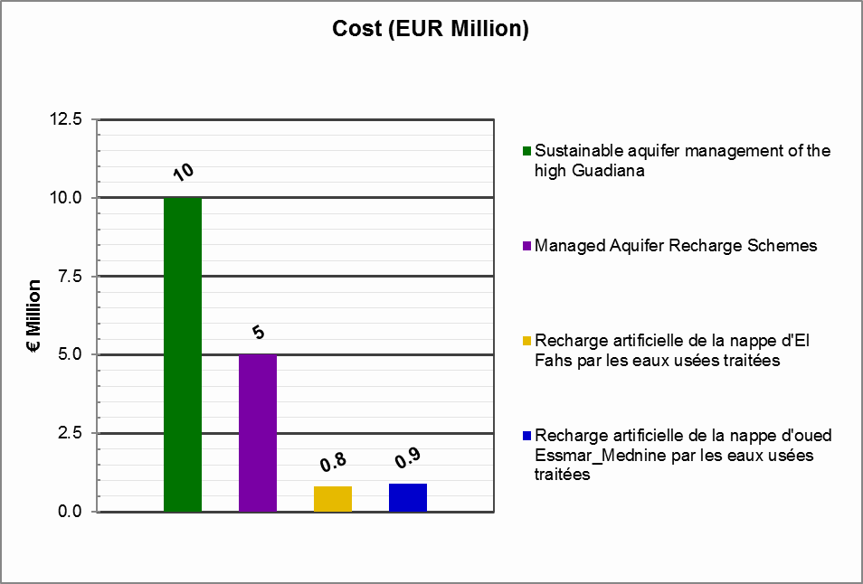
Figure 13 : Budgets for the projects included in Action 7: Sustainable aquifer management
The timelines for implementation are very variable, ranging from 24 to 72 months.
On a valued chronogram, this Action would look as follows:
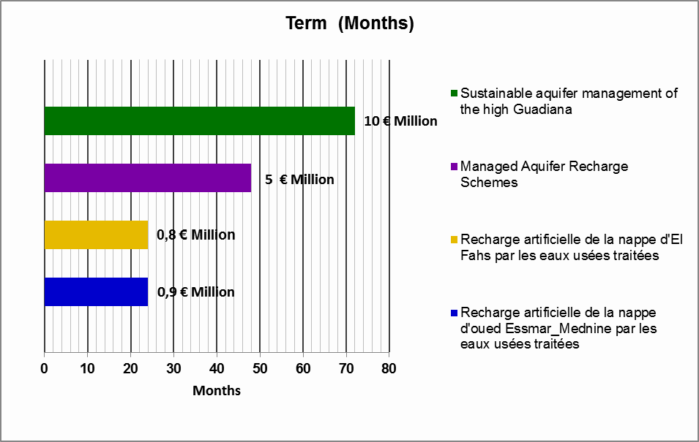
Figure 14 : Timeline for the implementation of the projects included in Action 7: Sustainable aquifer management

Action 8. Promoting re-use
Besides conventional resources, the commitment to make use of non-conventional resources (reuse and desalination) should be encouraged, all the more in countries presenting the characteristics of the Mediterranean basin where water is a precious and scarce resource.
From the analysis of the projects received by the member countries and observers, it can be concluded that reuse is a theme that arises great interest.
Therefore, the Plan puts forward the following Action in the field of the improvement of wastewater in order to subsequently reuse it for a variety of purposes, while previously evaluating the possibilities and the eventual risks of treating and using wastewater and meeting the standards of quality established in the legislation.
The projects included in this Action are the following:
Project | Title | Promoting country/ entity | Promoter | Geographical scope | Strategy block | Cost (EUR Million) | Term (months)
18 | Comparative analysis reuse in the Western Mediterranean | ES | Spain | Regional  Western Mediterranean | 2 | 0,5 | 24
21 | Réutilisation des eaux usées épurées et développement de son utilisation | DZ | Ministère Algérien des Ressources en Eau et de l'Environnement | National | 2 | 0,6 | 24
29 | Decentralized treated waste water improvement for irrigation | TN | Ministry of Agriculture | National  Centre and south areas inside the country (20 pilot projects) | 3 | 3 | 60
31 | Promoting the treated wastewater reuse as a means of coping with climate change | MA | Moroccan delegate Ministry in charge of Water | Regional | 3 | 2,3 | 120
55 | Floating islands pilot-project of Colibri in Morocco | MA | Global Colibri (PT) | Local (Morocco) | 3
Table nº 11 : Projects included in Action 8: Promoting re-use
All the proposed projects are national, except for the Project proposed by Spain that has a regional scope. Through this Project, the situation of reuse in each of the member countries would be analysed, to obtain the state of the art of the different reuse techniques including their advantages and disadvantages; the results could serve as a basis to address the 4 projects included with a national scope, each of them having a specific objective.
Besides, these projects are closely related to project 30 included in Action 3 “Training and Capacity Building” where actions geared to the professionalization of the sector through the development of capacities and exchange of information, will be carried out.
The Project “Promoting the treated wastewater reuse as a means of coping with climate change” proposed by Morocco has a budget of 22.3 Million €, of which 20 are allocated to pilot projects.
The objectives to achieve with these projects respond to priority 4 “capacity building”, priority 10 “Increasing and mobilising the available resources” and priority 13 “Protection of water quality and biodiversity”. On the one hand, these projects improve the quality of water and therefore also that of the associated ecosystems, increasing biodiversity. On the other hand, they increase the availability of resources while being able to respond to increases of the demand and facing the reduction of resources due to climate change.
The total budget of this Action is 6,4 Million € (in the absence of the budget of the Project proposed by Portugal), distributed as follows:
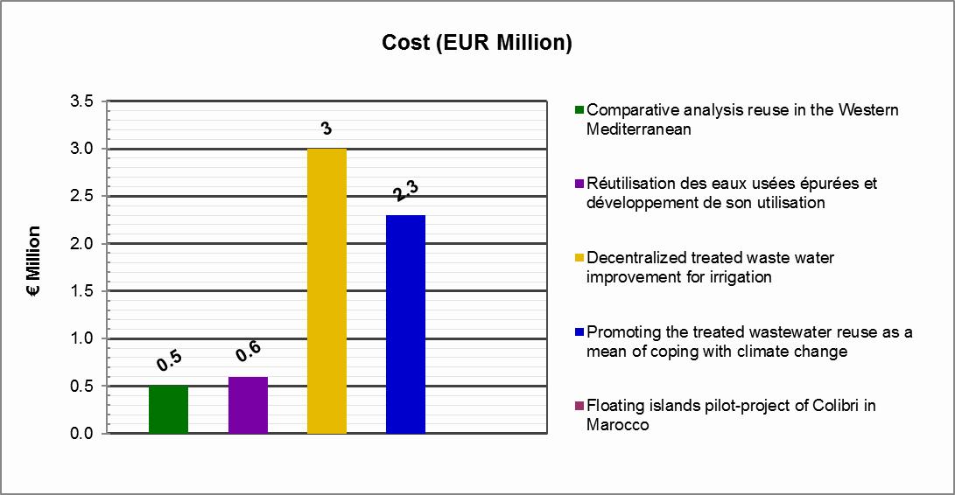
Figure 15 : Budgets for the projects included in Action 8: Promoting re-use
The timelines for implementation are very variable, ranging from 24 months to 120.
On a valued chronogram, this Action would look as follows:
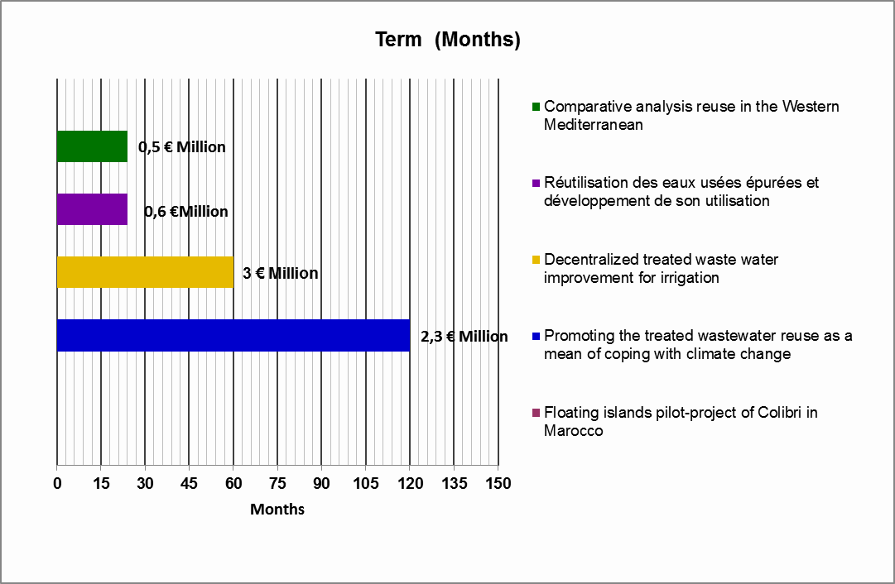
Figure 16 : Timeline for the implementation of theprojects included in Action 8: Promoting re-use

Action 9. Improvement of the quality of water
Sources of pollution are numerous all over the Mediterranean region. A number of measures need to be applied in order to achieve, in the medium term, a good status for all waters based on a comprehensive monitoring system for water quality and quantity and for ecosystems and biodiversity. These measures would include reducing and preventing water pollution, expanding the scope of water protection and avoiding overexploitation of water resources. In addition, the use of fertilisers and pesticides should be limited to appropriate and recommended levels.
The Action Plan addresses the quality of waters from different points of view namely the improvement of the quality of drinking water, of sanitation systems, and of groundwater. The most important is that related to the quality of wastewater since various countries have shown an interest through national projects. These projects have been included in the previous Action.
As regards the quality of drinking water, sanitation systems and groundwater, these are the three existing projects:
Project | Title | Promoting country/ entity | Promoter | Geographical scope | Strategy block | Cost (EUR Million) | Term (months)
49 | Promoting sanitation systems in rural areas | MA | Moroccan delegate Ministry in charge of Water | Regional | 3 | 4 | 120
50 | Minimise pollution effect of the oil disposal swamps to the groundwater aquifer | LY | Ministry of Water Resources | Local (North east of oil field of Libya) | 3 | 5 | 24
52 | Improve the quality of drinking water in Mauritania | MR | Ministère de l'hydraulique et de l'Assainissement | National | 3 | 0,8 | 36
Table nº 12 : Projects included in Action 9: Improvement of the quality of water
All projects directly develop priority 13 “Protection of water quality and biodiversity”, each of them focusing on a specific aspect but sharing the common objective of improving the quality of water and therefore improving their associated ecosystems and protecting biodiversity. These are national projects demanded by southern countries. Northern countries could support technically those from the south on issues where they have more experience.
The total budget of this Action is 9.8 Million €, distributed as follows:
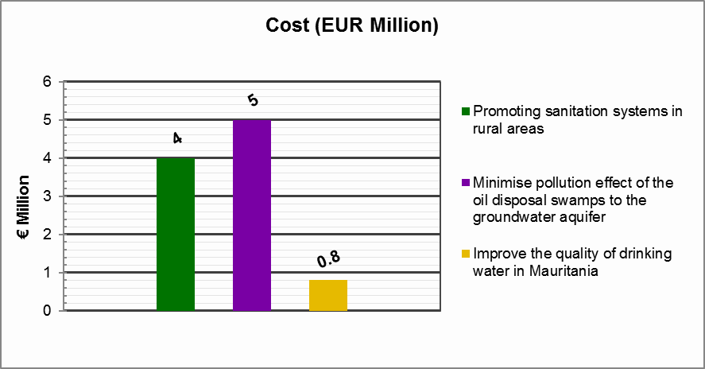
Figure 17 : Budgets for the projects included in Action 9: Improvement of the quality of water
The timelines for implementation are very varied, ranging from 24 months to 120.
On a valued chronogram, this Action would look as follows:
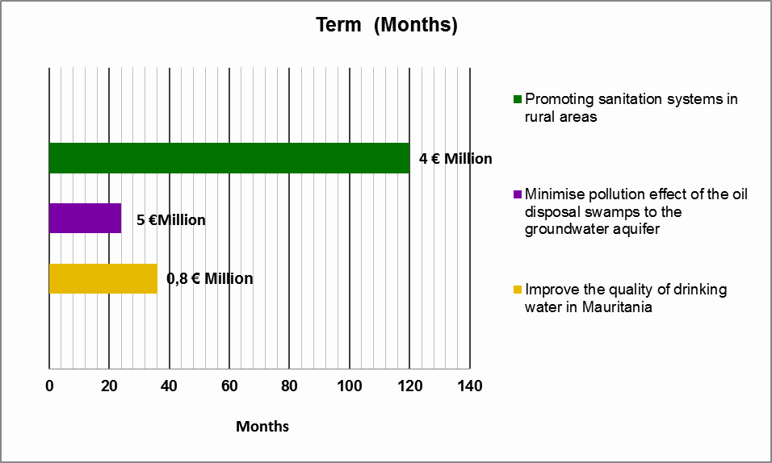
Figure 18 : Timeline for the implementation of the projects included in Action 9: Improvement of the quality of water

Action 10. Preservation of aquatic ecosystems
Throughout the process of elaboration of the Plan, a high interest in aquatic ecosystems and in particular on wetlands, arose among some of the members. As a result of such interest, this Action is proposed to be developed regarding the management and quality of wetlands in the Mediterranean.
Wetlands are essential due to the numerous benefits or to the ecosystem-related services that they bring to mankind, from the supply of fresh water, food, biodiversity to flood control, groundwater recharge and climate change mitigation. Therefore, through the Action Plan, special emphasis will be given to improve wetlands quality and management.
Within this Action, we find two projects presented by the countries; one project promoted by Spain aiming to achieve a good ecological status in the wetland of the Albufera of Valencia, and another promoted by Morocco, related to legislative aspects essential to the achievement of the goals.
Project | Title | Promoting country/ entity | Promoter | Geographical scope | Strategy block | Cost (EUR Million) | Term (months)
1 | Implementation of a new law for the protection of aquatic areas | MA | Moroccan delegate Ministry in charge of Water | National | 1 | 4,5 | 120
48 | Special Plan for achieving the ecological potential of the RAMSAR wetland of the Albufera Lake. | ES | Spain | Local (lake of the Albufera) | 3 | 0,72 | 24
56 | Assessing and managing pressures on water and wetlands in the Mediterranean through the Water Footprint indicators | Medwet/MWO/WFN/EMWIS/UNEP | Medwet/MWO/WFN/EMWIS/UNEP | Regional | 3 | 3,6 | 36
Table nº 13 : Projects included in Action 10: Preservation of aquatic ecosystems
The main priorities covered by these projects are priority 1 “Governance development and/or consolidation” with the development of new legislation, and priority 13 “Protection of water quality and biodiversity” promoting biodiversity of ecosystems.
The total budget of this Action is 8,82 Million €, distributed as follows:
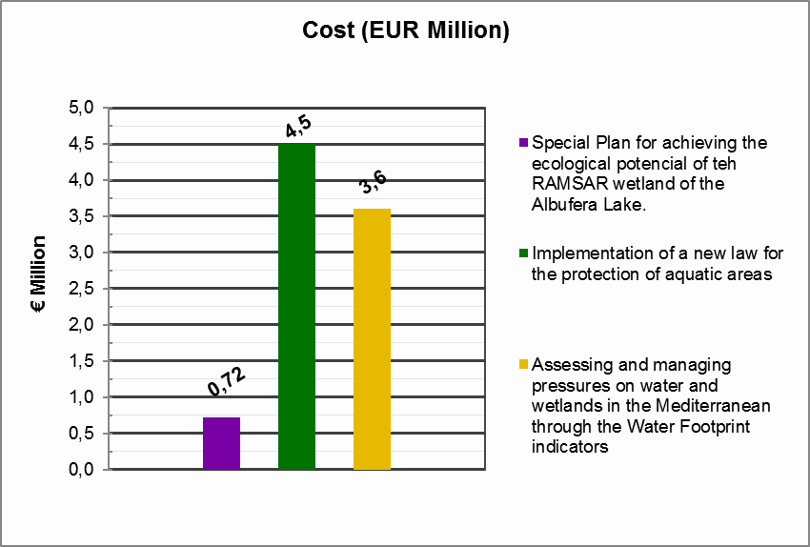
Figure 19 : Budgets for the projects included in Action 10: Preservation of aquatic ecosystems
The timelines for implementation periods are very varied, ranging from 24 months to 120.
On a valued chronogram, this Action would look as follows:

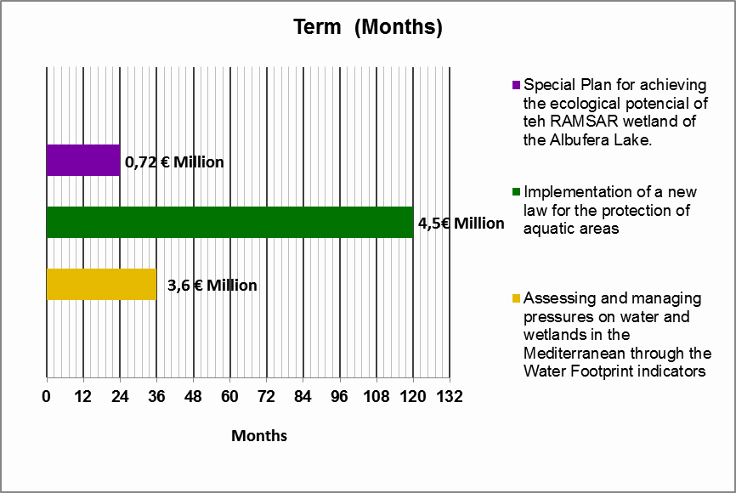
Figure 20 : Timeline for the implementation of the projects included in Action 10: Preservation of aquatic ecosystems

Infrastructure actions
Within the Actions promoted below, a total of 6 proposed projects are included, which entail a total budget of approximately 280 Million €.

Action 11. Infrastructure projects in Libya
The infrastructure projects in Libya present 4 different types: construction of dams, recharge of aquifers, desalination plants and water treatment plants, all of them aiming at increasing available resources. The first three types mainly address priority 10 “Increasing and mobilising the available resources”, and the fourth one addresses priority 13 “Protection of water quality and biodiversity” and also priority 7 “De-pollution of the Mediterranean” since it is developed in coastal cities and the water discharged into the sea would have a better quality.
Project | Title | Promoting country/ entity | Promoter | Geographical scope | Strategy block | Cost (EUR Million) | Term (months)
33 | Artificial discharge to the groundwater aquifers | LY | Ministry of Water Resources | Local  North west area of Libya (1 pilot project) | 3 | 10 | 36
36 | Construction of dams | LY | Ministry of Water Resources | National (seven dams) | 3 | 115 | 48
51 | Water Sewage Treatment Project (Phase I) | LY | Ministry of Water Resources and wastewater company | Local  Along the Libyan coast nearby the cities, northern coast of the country | 3 | 12 | 60
60 | Desalination plants to improve domestic water supply | LY | The General Desalinisation Company  Ministry of Water Resources | National  Along the Libyan Coast nearby the Cities, Northern coast of the country | 3 |  | 72
Table nº 14 : Projects included in Action 11: Infrastructure projects in Libya
The total budget of this Action is 137 Million €, distributed as follows:
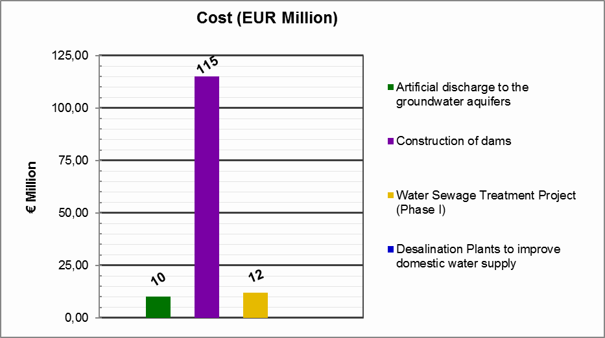
Figure 21 : Budgets for the projects included in Action 11: Infrastructure projects in Libya
The timelines for implementation are very varied ranging from 36 months to 72.
On a valued chronogram, this Action would look as follows:
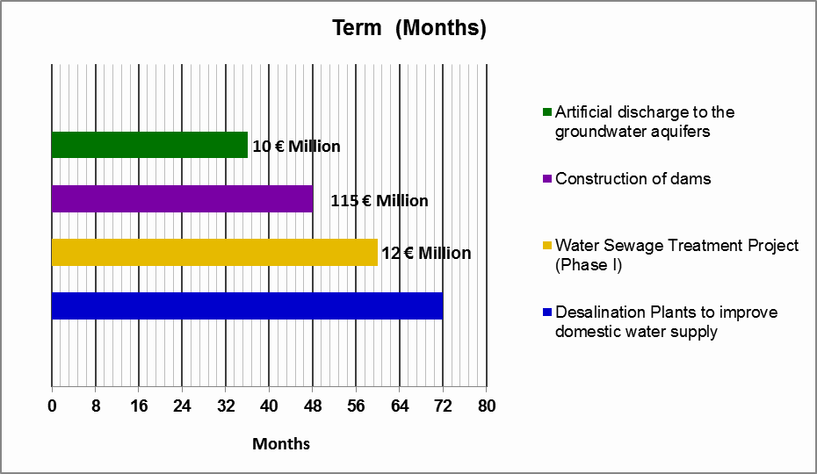
Figure 22 : Timeline for the implementation of the projects included in Action 11: Infrastructure projects in Libya

Action 12. Infrastructure projects in Malta
With the aim of increasing resources availability in Malta, the purpose is to achieve a production and distribution of 7 Million m³ of highly polished treated effluent. To this end, the following project is proposed, which would develop priority 10 “Increasing and mobilising the available resources”
Project | Title | Promoting country/ entity | Promoter | Geographical scope | Strategy block | Cost (EUR Million) | Term (months)
32 | Production and distribution of highly polished treated effluent | MT | WSC | National | 3 | 22 | 36
Table nº 15 : Projects included in Action 12: Infrastructure projects in Malta
This project entails the development of three polishing plants situated in the islands’ three wastewater treatment plants which will enable the treatment (polishing) of effluent to high quality levels which will enable its safe reuse. Furthermore, the project envisages the development of a dedicated distribution network to enable the availability of the highly polished effluent at the point of use.
The total budget of this Action is 22 Million €, with an implementation timeline of 36 months.
On a valued chronogram, this Action would look as follows:
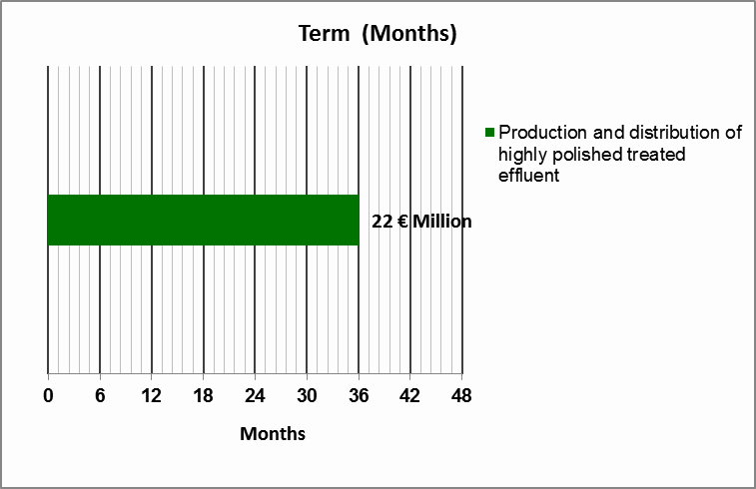
Figure 23 : Timeline for the implementation of the projects included in Action 12: Infrastructure projects in Malta

Action 13. Reduction of flood risk in the Júcar River Basin, Spain.
The rivers of the Western Mediterranean are characterised by an extreme flow regime causing strong river floods, provoking overflowing of channels, floods throughout their course, and causing significant damage to the fields and populated areas they reach. A great number of measures could reduce the flood risk. These measures are classified into structural and non structural measures.
In the Júcar Basin, the existing Global Plan against the flood risk aims at minimising the damages caused by floods that periodically affect the Júcar River banks. In this Action, measures of the Plan related to green infrastructure are included (refurbishment and adaptations of riverbanks, green corridors) in order to reduce the flood risk by carrying out integrated and sustainable actions that make compatible the protection against flooding with the recovery and improvement of inland waterways preserving their function as a backbone corridor of the territory. With this project, priority 12 (“Flood prevention”) is covered.
Project | Title | Promoting country/ entity | Promoter | Geographical scope | Strategy block | Cost (EUR Million) | Term (months)
47 | Actions of the Global Plan for flood risk in the Júcar river | ES | Spain | Local  Jucar river | 3 | 120 | 48
Table nº 16 : Projects included in Action 13: Reduction of flood risk in the Júcar River Basin, Spain
The total budget of this Action is 120 Million €, with a timeline for implementation of 48 months.
On a valued chronogram, this Action would look as follows:
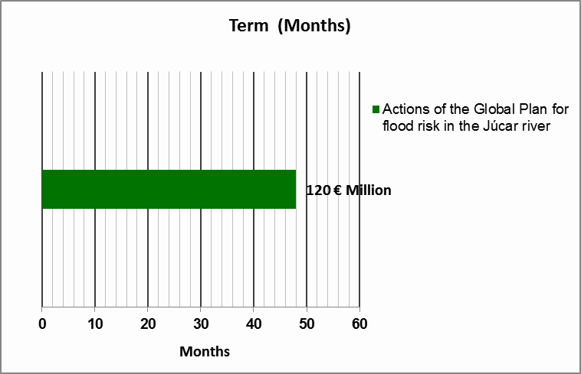
Figure 24 : Timeline for the implementation of the projects included in Action 13: Reduction of flood risk in the Júcar River Basin, Spain

Donors
In order to secure a high degree of success in the development of the Action Plan it is a condition sine-qua-non to obtain the support of the main financial entities be they worldwide, national or regional which may contribute to the development of the Project.The search for financing and the implementation of the Action Plan will be the main goal of the follow-up Plan. The funding issue will be addressed at a later stage immediately after the Ministerial endorsement.
Each entity has a specific profile and scope of application. Therefore, it is necessary to make them aware of the project by implementing the relevant actions that enable them to analyse which of the projects fits best their criteria and priorities.
That is why the financial entities will be systematically invited to the technical meetings that will be organised throughout the process of the Action Plan, where they will be required to indicate their suggestions and preferences and be able to hear the needs of each country or organisation.
This Action Plan will be the starting point to hold tailor-made meetings organised with the financial entities addressing any particular theme. All these actions are detailed in the dissemination Plan of the Action Plan. Participation requests will be duly addressed by all means.
A list of the said entities, identified as possibly interested, is set out below. This list could be subject to modifications and expansions.
INSTITUTION | Acronym | Country
Agencia Española de Cooperación Internacional para el Desarrollo | AECID | Spain
Agence Française de Développement | AFD | France
African Development Bank Group | BAD | Tunisia
European Bank for Reconstruction and Development | BERD | England
European Investment Bank | BEI | Luxembourg
European Union* | EU | Belgium
Foundation Prince Albert II of Monaco | FPA2 | Monaco
Global Environment Fund | GEF | USA
KFW Group | KFW | Germany
Marseille Centre for Mediterranean Integration | CMI | France
OPEC Fund for International Development | OFID | Austria
Swedish International Development Cooperation Agency | SIDA | Sweden
World Bank | WB | USA
* Developed below
Table nº 17 : Potential donors
The European Union has several mechanisms in regard to financing and cooperation with the Mediterranean. Each one is characterized by specific objectives and features. During the elaboration process of this Plan, there has been close contact with the European Commission in order to adapt the Action Plan to the suggestions made. Nevertheless, a high level meeting with the responsible representatives will be necessary in order to present the approved Action Plan and analyse the existing financing possibilities.
The following se are the main existing cooperation tools:
- Within the H2020 initiative:
- MeHSIP-PPIF aims to support the Horizon 2020 Investments for Pollution Reduction and Prevention component.
- Capacity Building/Mediterranean Environment Program (€5 million for 2009-2012) aims to support the implementation of the Horizon 2020 Initiative Capacity Building component through capacity building and awareness raising activities, and to promote integration/mainstreaming of environment issues into other sector policies. A new phase with €4 million EU support will be launched in 2015 and will be merged with SWIM support mechanism
- Shared Environment Information System (SEIS) was created to support the Horizon 2020 Initiative Monitoring and Review component in order to monitor the success of the Horizon 2020 Initiative and the state of the Mediterranean Sea.
- Within the neighborhood projects:
- SWITCH-Med is an EU funded Program whose aim is to assist 10 countries of the southern Mediterranean to develop and implement policies to SWITCH to sustainable pattern of consumption and production (SCP) promoting it among consumers, small and medium‐sized enterprises and Mediterranean policy‐makers
- SWIM (Sustainable Water Integrated Management) with €20.6 million of EU support for 2010-2014 is a Regional Technical Assistance Programme launched by the European Commission to contribute to the extensive dissemination and effective implementation of sustainable water management policies and practices in the Southern Mediterranean Region.
- Marine Protected Areas: the EU is supporting the creation of a network of Marine Protected Areas through the project “Development of a Mediterranean Marine and Coastal Protected Areas Network.
- NGOs Project - 'Strengthening Environmental Governance by Building the Capacity of Non-Governmental Organizations' is a project funded by the European Union, implemented by the United Nations Development Program (UNDP). The project aims to promote sustainable development and improve environmental management in target countries.
Additionally, there are other financing sources such as:
- Taiex is the Technical Assistance and Information Exchange instrument of the European Commission. TAIEX supports public administrations with regard to the approximation, application and enforcement of EU legislation as well as facilitating the sharing of EU best practices. http://ec.europa.eu/enlargement/tenders/taiex/index_en.htm.
- Association Agreement Programs with countries from the region. These agreements are currently financing a twinning with Morocco and will finance another with Algeria. Both these projects are included in the Action Plan.
- Neighbour Investment Facility (NIF): http://ec.europa.eu/enlargement/neighbourhood/neighbourhood-wide/neighbourhood-investment-facility/index_en.htm Applicable to Egypt, Jordan, Lebanon, Morocco, Palestine*, Tunisia as well as regional south-wide projects.

Dissemination
In order to pave the way for a better implementation of the Action Plan, a number of activities will be carried out to present and disseminate the Action Plan. In addition, these activities will facilitate mobilisation of funds for project proposals in the Action Plan.
The dissemination of the Action Plan is considered of the utmost importance. Thus, a separate document will be created named Dissemination Plan, which will include all the information related thereto.
This will be an annual Plan in which the procedures to be developed in order to carry out an appropriate dissemination of the Action Plan, will be defined. It will include the meetings to be held be they technical or that with the donors. It will also include the events with the Mediterranean and specific workshops deemed to be of interest. The particular way of intervention in each of them will be specified.
A list of web platforms where the information can be accessed will be elaborated. In addition, the creation and update of the web of the Water Strategy in the Western Mediterranean will be addressed.

Monitoring and updating Action Plan
The Action Plan is a living document to be enriched by projects that may have either been already implemented, that are being implemented at the moment, or foreseen to be implemented in a short-medium term.
As a living document, the implementation of projects included in the Action Plan should be monitored. This monitoring will be an ongoing process which can start as soon as projects are included in the first draft. It should continue along the drafting process of the Action Plan, and after its endorsement by Ministers.
In the course of this monitoring, the following actions will be developed:
1. Period of reception / modification of new project proposals.
2. Processing of new proposals, evaluation and classification. Updating the Action Plan.
Moreover, the Plan may be consistently enhanced with new projects that share a regional dimension, because they may be executed by several countries or because their innovative advances are worth replicating regionally. Progress made on the implementation of the Action Plan should therefore be reviewed consistently and periodically.
In the successive versions of the Action Plan, the possibility of prioritizing projects using objective criteria would be considered while allowing determining the appropriateness of developing certain projects prior to others. Those criteria of prioritisation will be subject to the consensus of all members and will be in compliance with the goals of the Strategy.
The tasks related to the monitoring of the development of the Action Plan correspond to the Ministerial Group on Water of the 5+5 (MGW) Dialogue, which will be assisted by a Technical Working Group (WG) composed of the representations of the administrations of the member countries and with the logistic, technical and administrative support of the Technical Secretariat (TS) operated by the Mediterranean Network of Basin Organisations (MENBO).
These tasks focus on supervising the development of the projects underway and on the assessment of the progress made in the implementation of the Plan. In addition, new working lines and projects will be identified to be included in the Plan, as well as any measure necessary to achieve the objectives of the Strategy and a revision of its priorities.
The specific development of these tasks and the functions of the abovementioned groups (MWG 5+5, WG, TS) are detailed in the separate document “Rules of Procedure”.

Annex
- Annex 1: List OF RECEIVED PROJECTS classified by promotEr
A total of 60 projects have been received. In the following table the projects presented are shown according to the promoter:
COUNTRY/ORGANISATION | NUMBER OF PROJECTS
LIBYA (LY) | 6
TUNISIA (TN) | 7
MOROCCO (MA) | 5
MAURITANIA (MR) | 3
ALGERIA (DZ) | 3
PORTUGAL (PT) | 6
FRANCE (FR) | 2
MALTA (MT) | 4
ITALY (IT) | 4
SPAIN (ES) | 7
International Office for Water (OIEAU)  Institut Méditerranéen de l’Eau (IME) | 1
European Union (EU) | 3
Global Water Operators’ Partnerships Alliance (GWOPA) | 1
The United Nations Economic Commission for Europe (UNECE) | 1
IME  Centre for Mediterranean Cooperation) (IUCN Med)  MIO ECSDE (Mediterranean Information Office for Environment, Culture and Sustainable Development)  RAED (Arab Network for Environment and Development)  WWF Mediterranean Program Office (WWF MedPO) | 1
Global Water Partnership Mediterranean (GWP-Med)  The Organisation for Economic Co-operation and Development (OECD) | 1
Mediterranean Network of Basin Organisations (MENBO) | 2
The Mediterranean Wetlands Initiative (MedWet)  The Mediterranean Wetlands Observatory (MWO)  The Water Footprint Network (WFN)  Plan Bleu – Environment and Development in the Mediterranean (UNEP/MAP)  Euro-Mediterranean Information System on know-how in the Water Sector (EMWIS) | 1
Mediterranean Agronomic Institute of Zaragoza (IAMZ-CIHEAM) | 1
Institut de Prospective Économique du Monde Méditerranéen (IPEMED) | 1
TOTAL | 60
The project proposals received by each promoter are indicated below:
- LIBYA
Presents 6 projects:
- Central database for water resource in Libya.
- Pollution effect of the oil disposal swamps to the groundwater aquifer.
- Water Sewage Treatment Project (Phase I)
- Artificial Discharge to the groundwater aquifers.
- Construction of Dams.
- Desalination Plants to improve domestic water supply

- TUNISIA
Presents 7 projects:
- Decentralized treated waste water (improvement of irrigation treated wastewater quality).
- Water harvesting systems in urban areas.
- Use of innovative technologies and approaches for the monitoring of the water resources of Grombalia region.
- Création d’un Barrage sur Oued El Htab et création d’un projet de développement intégré dans son Bassin Versant.
- Dévasement du Barrage El Kébir
- Recharge artificielle de la nappe d'El Fahs par les eaux usées traitées
- Recharge artificielle de la nappe d'oued Essmar_Mednine par les eaux usées traitées

- MOROCCO
Presents 5 projects:
- Monitoring the use of water resources in Morocco
- Promoting sanitation systems in rural areas
- Promoting the treated wastewater reuse as a mean of coping with climate change
- Seawater desalination by using renewable energy
- Implementation of a new law for the protection of aquatic areas
Morocco is also a promoter of the Project financed together with the EU “Integrated Water Resources Management and Governance in Morocco”

- MAURITANIA
Presents 3 projects:
- Enhance the capacities of actors of the water sector in Mauritania
- Enhance the governance of the hydrological sector in rural and semi-urban areas in Mauritania
- Improve the quality of drinking water in Mauritania

- ALGERIA
Presents 3 projects:
- Renforcement des capacités de gouvernance des ressources en eau
- Réutilisation des eaux usées épurées et développement de son utilisation
- Adaptation aux conséquences des changements climatiques

Algeria is also a promoter of the Project financed together with the EU « Governance and integrated water resources management in Algeria »

- PORTUGAL
Presents 6 projects:
- A new approach for multi-stakeholder engagement: the Water Living Lab network
- Towards sustainable intensification in agriculture
- Environmental Performance Review (EPR) of the Kingdom of Morocco
- Studies and projects for the irrigation project of Gharb
- Supervising of irrigation works in Morocco
- Floating islands pilot-project of Colibri in Morocco

- FRANCE
Presents 2 projects:
- Professionalizing the water REUSE to tackle water issues in the western Mediterranean. Ecofile
- Plan bassin d’adaptation au changement climatique Rhone-Méditerranée.
France is also the promoter of the Project “Mediterranean Water Knowledge Platform” that has been presented by the Institut Méditerranéen de l’Eau IME), the Euro-Mediterranean Information System on the Know-how in the Water Sector (EMWIS), the International Office for Water in France (OIEau) and the Mediterranean Network of Basin Organisations (MENBO).

France also proposes, as a Technical Secretariat of the Medwet, to develop a project on the management and quality of wetlands “Assessing and managing pressures on water and wetlands in the Mediterranean through the Water Footprint indicators”.
- MALTA
Presents 4 projects:
- Production and distribution of highly polished treated effluent
- Managed Aquifer Recharge Schemes
- National Water Conservation Campaign
- Establishment of a Water Scarcity and Drought assessment platform

- ITALY
Presents 4 projects:
- Climate change mitigation Action in urban areas in the Western Mediterranean
- Full application of FCR (full cost recovery) principle and PPP (polluter pays principles)
- Innovative hydro-economic modelling as leverage to reduce pressure on water stressed basins in the Western Mediterranean
- Executive Information System for the governance and management of Water Resources in the Western Mediterranean

- SPAIN
Presents 7 projects:
- Special Plan for achieving the ecological potential of the RAMSAR wetland of the Albufera Lake
- Comparative analysis of water reuse in the Western Mediterranean.
- Actions of the Global Plan for flood risk in the Júcar river.
- Actions for the sustainable aquifer management in High Guadiana.
- Sustainability (environmental, economic and social) of dams in the Westerns Mediterranean
- Water use monitoring of irrigated agriculture in ES by earth observation WATER-EO (the University of Castilla La Mancha is also promoter of this project)
- Training and capacity building in governance and water resources management. IEA Foundation, University of Murcia, Government of Murcia
Spain also participates in the following two projects presented by regional organisations:
- “Mediterranean Water Knowledge Platform” presented by the International Office for Water (OIEAU) and the Institut Méditerranéen de l’Eau (IME)
- “Hydrological consequences of climate change in W.MED” presented by MENBO
- OTHERS
International Office for Water and IME: Mediterranean water knowledge Platform.
European Union: Sustainable water integrated management (SWIM) program-phase II.
European Union/MA: Integrated Water Resources Management and Governance in Morocco.
European Union/ALG: Governance and integrated water resources management in Algeria.
GWOPA: 5+5 Water Operators’ partnership platform.
UNECE: Water Convention: global framework for transboundary water cooperation.
IME-IUCN Med, MIO ECSDE, RAED, WWF MedPO: BlueGreen Med-CS.
GWP-Med-OECD: Governance and financing for the Mediterranean Water Sector.
MENBO: Hydrological consequences of climate change in W.MED.
A cross-cutting study on a dynamic analysis of the coherence between national policies and the Water Strategy in the Western Mediterranean
Medwet/MWO/WFN/EMWIS/UNEP: Assessing and managing pressures on water and wetlands in the Mediterranean through the Water Footprint indicators
IAMZ-CIHEAM: Training actions to support the implementation of projects that develop the priorities of the Water Strategy for the Western Mediterranean
IPEMED: Implementation and Management of Innovative Funding Mechanisms to ensure access to water and sanitation in the Mediterranean
A summary of all the projects and their main features is included in the annex 2.

- Annex 2: Projects’ sheets

- Annex 3: Analysis of the projects
A total of 60 projects have been received. The following features of each of them have been described:
- Title
- Promoting country/entity
- Description and main objectives
- Geographical scope
- Concordance with the priority themes of the Strategy
- Budget and foreseen funding
- Current status
- Indicators
- Duration
With the aim to address the specific challenges of water in the Western Mediterranean, the Strategy defines 13 priorities comprised in three mail blocks. The order of the 13 priority issues does not respond to a higher importance of some over others, but to the grouping of the issues into three thematic blocks, from more general principles to more specific interest in water management in the Western Mediterranean.
The three thematic blocks have been defined starting by the cross-cutting subjects and widely accepted basic orientations on water management. The second block describes the regional interest issues adapted to the specific context of the Western Mediterranean, and the third block focuses on more technical objectives for promoting water management improvement.
The three thematic blocks are aimed at:
Block 1: Enhancing Western Mediterranean country policies’ convergence towards the general principles of a sustainable water policy.
Block 2: Fostering cooperation on regional interest matters.
Block 3: Promoting water management improvement.
The projects presented are encompassed within these blocks in the following manner.
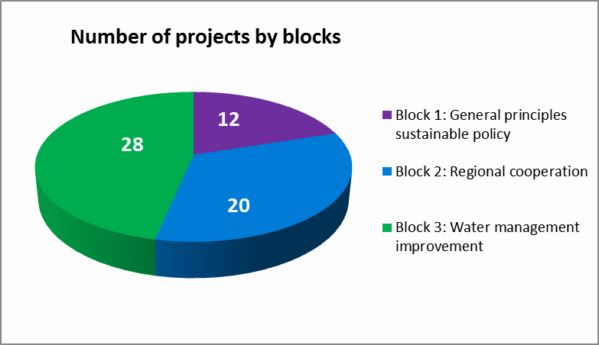
Figure 25 : Number of projects by blocks
As can be observed, almost 50% of the projects presented are included in the third block related to specific projects focusing on the improvement of resource management.
Taking a closer look at each block, the main priorities that have been developed can be observed. The Strategy defines the following 13 priorities classified according to the block they belong to:
Block 1: Enhancing Western Mediterranean country policies’ convergence towards the general principles of a sustainable water policy.
Priority 1: Developing and starting up clearly defined legal frameworks
Priority 2: Establishing governance adapted to integrated water management
Priority 3: Implementing cost-recovery
Block 2: Foster cooperation in relation to regional matters.
Priority 4: Capacity building
Priority 5: Innovation development in the water sector.
Priority 6: Water-energy-food nexus
Priority 7: De-pollution of the Mediterranean
Priority 8: Mobilising water-related innovative financing solutions for the application of the Strategy
Block 3: Promoting water management improvement
Priority 9: Climate change adaptation
Priority 10: Increasing and mobilising the available resources
Priority 11: Water use efficiency improvement
Priority 12: Flood prevention
Priority 13: Protection of water quality and biodiversity
Although every project could be included in various categories, the classification has been made based on the priority that better corresponds to the objectives of the project. Following this classification, the number of projects within each category is shown below:
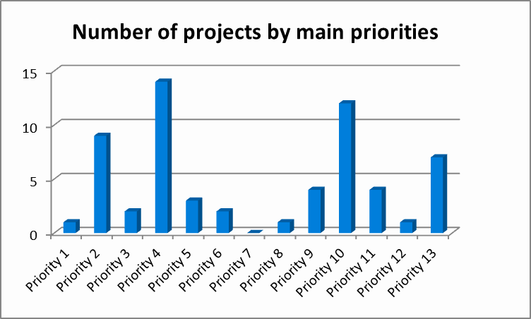
Figure 26 : Number of projects by main priorities
The most often addressed priorities are number 4 (Capacity building) with 14 projects presented, followed by number 10 (Increasing and mobilising the available resources) with12 projects. This reflects the need to exchange experiences, common work and improvement of knowledge among the member states. The other priority reflects the need to an increase of water resources in countries constantly growing and suffering from scarcity of resources, characteristic of the Mediterranean region and particularly of southern countries
As shown below, projects whose main priority is number 10 are mostly developed in the Maghreb countries.
Followed by these two priorities, are priorities number 2 “Establishing governance adapted to integrated water management”, number 13 “Protection of water quality and biodiversity”, number 9 “Climate change adaptation” and number 11 “Water use efficiency improvement”, with 9, 7, 4 and 4 projects, respectively. This fact reflects the importance of the governance issues, quality of water and biodiversity, climate change and, as well as the need to improve the sustainable use of water.
Below, we set out the projects presented for each of the most prominent priorities mentioned above:
The projects whose main priority is number 4 “capacity building” are:
- Sustainable Water Integrated Management (SWIM) Program – phase II (European Commission)
- Mediterranean Water Knowledge Platform (IOW-IME)
- 5+5 Water Operators´ Partnership Platform (GWOPA)
- BlueGreen- Networking civil society in the Mediterranean Region (IME/IUCN/ MIO-ECSDE/ RAED / WWF)
- Establishment of a Water Scarcity and Drought assessment platform (Malta)
- Training and capacity building in governance and water resources management (Spain, IEA)
- Enhance the capacities of actors of the water sector in Mauritania (Mauritania)
- Comparative analysis reuse in the Western Mediterranean(Spain)
- Sustainability (environmental, economic and social) of dams in the Western Mediterranean (Spain).
- Renforcement des capacités de gouvernance des ressources en eau (Algeria)
- Réutilisation des eaux usées épurées et développement de son utilisation (Algeria)
- Training actions to support the implementation of projects that develop the priorities of the Water Strategy for the Western Mediterranean (IAMZ-CIHEAM).
- Integrated Water Resources Management and Governance in Morocco (EU/MA)
- Governance and water resources integrated management in Algeria (EU/ALG)
The majority of projects promoted by regional organisations or observers belong to category number 4 focusing on knowledge exchange and experiences among various countries of the 5+5.
The projects whose main priority is number 10 “Increasing and mobilising the available resources” are:
- Decentralized treated waste water improvement for irrigation (Tunisia)
- REUSE-PRO: Professionalizing the water REUSE to tackle water issues in the western Mediterranean (France, Ecofile)
- Promoting the treated wastewater reuse as a means of coping with climate change (Morocco)
- Production and distribution of highly polished treated effluent (Malta)
- Artificial discharge to the groundwater aquifers (Libya)
- Construction of dams (Libya)
- Water harvesting systems in urban areas (Tunisia)
- Création d’un Barrage sur Oued El Htab et création d’un projet de développement intégré dans son Bassin Versant (Tunisia)
- Dévasement du Barrage El Kébir (Tunisia)
- Recharge artificielle de la nappe d'El Fahs par les eaux usées traitées (Tunisia)
- Recharge artificielle de la nappe d'oued Essmar Mednine par les eaux usées traitées (Tunisia)
- Desalination plants to improve domestic water supply (Libya)
The following most developed priority in the projects is number 2 “Establishing governance adapted to integrated water management”, within which 9 projects based on water governance and on integrated water management are included. The projects are the following:
- Central database for water resource in Libya (Libya)
- Monitoring the use of water resources in Morocco (Morocco)
- Environmental Performance Review (EPR) of the Kingdom of Morocco
- Enhance the governance of the hydraulic sector in rural and semi-urban areas in Mauritania (Mauritania)
- Sustainable aquifer management of the high Guadiana (Spain)
- Water Convention: global framework for trans-boundary water cooperation (UNECE)
- Innovative hydro-economic modelling as leverage to reduce pressure on water stressed basins in the Western Mediterranean (Italy)
- Executive Information System for the governance and management of Water Resources in the Western Mediterranean (Italy)
- A cross-cutting study on a dynamic analysis of the coherence between national policies and the Water Strategy in the Western Mediterranean (Technical Secretariat of the MGW 5+5, MENBO)
As it has been mentioned above, projects that relate to the protection of the quality of water and to biodiversity are also well represented (priority number 13). Within this category, the following 7 projects developed in the southern countries, except for the Wetland of the Albufera and Medwet project, are included. These projects could also be extrapolated to any wetland of the Western Mediterranean.
- Special Plan for achieving the ecological potential of the RAMSAR wetland of the Albufera Lake (Spain)
- Promoting sanitation systems in rural areas (Morocco)
- Minimise pollution effect of the oil disposal swamps to the groundwater aquifer (Libya)
- Water Sewage Treatment Project (Phase I) (Libya)
- Improve the quality of drinking water in Mauritania (Mauritania)
- Floating islands pilot-project of Colibri in Morocco (Morocco/Global Colibri PT)
- Assessing and managing pressures on water and wetlands in the Mediterranean through the Water Footprint indicators (Medwet)
Followed by priority 13 appears priority 11 “Water use efficiency improvement” with 4 projects which cover the improvement of irrigation efficiency, the decrease of leaks in the network and public awareness campaigns. These projects are the following:
- Water use monitoring of Irrigated agriculture in ES by earth observation WATER-EO (Spain)
- Studies and projects for the irrigation project of Gharb (Morocco/Aquealogus PT)
- Supervise irrigation works in Morocco (Morocco/Coba PT)
- National Water Conservation Campaign (Malta)
And priority 9 “Climate change adaptation” with 4 projects:
- Hydrological consequences of climate change in W.MED. (MENBO)
- Plan bassin d’adaptation au changement climatique Rhône-Méditerranée (France)
- Adaptation aux conséquences des changements climatiques (Algeria)
- Climate change mitigation Action in urban areas in the Western Mediterranean (Italy)
None of the 60 projects has number 7 as its main priority “De-pollution of the Mediterranean”. Nevertheless, many of the projects do contribute to the reduction of pollution of the Mediterranean as for example all those related to sanitation, water treatment and improvement of water quality.
Regarding the following projects although priority number 7 has not been considered as the main priority, they still contribute significantly to fulfill this priority. As a result, this is a priority that deserves special attention:
- Implementation of a new law for the protection of aquatic areas (Morocco)
- Monitoring the use of water resources in Morocco (Morocco)
- REUSE-PRO: PROfessionalizing the water REUSE to tackle water issues in the western Mediterranean (Spain)
- Promoting the treated wastewater reuse as a mean of coping with climate change (Morocco)
- Production and distribution of highly polished treated effluent (Malta)
- Recharge artificielle de la nappe d'El Fahs par les eaux usées traitées (Tunisia)
- Special Plan for achieving the ecological potential of the RAMSAR wetland of the Albufera Lake (Spain)
- Promoting sanitation systems in rural areas (Morocco)
- Training actions to support the implementation of projects that develop the priorities of the Water Strategy for the Western Mediterranean (IAMZ-CIHEAM)
- Implementation and Management of Innovative Funding Mechanisms to ensure access to water and sanitation in the Mediterranean (IPEMED)
Each of the remaining priorities has less than four projects.
Priority 1: Developing and starting up clearly defined legal frameworks
- Implementation of a new law for the protection of aquatic areas (Morocco)
Priority 3: Implementing cost-recovery
- Governance & financing for the Mediterranean Water Sector (GWP-Med+OECD)
- Full application of FCR principle and PPP (Italy)
Priority 5: Innovation development in the water sector
- Managed Aquifer Recharge Schemes (Malta)
- Use of innovative technologies and approaches for the monitoring of the water resources of Grombalia region (Tunisia)
- A new approach for multi-stakeholder engagement: the Water Living Lab network (Portugal)
Priority 6: Water-energy-food nexus
- Seawater desalination by using renewable energy (Morocco)
- Towards sustainable intensification in agriculture (Portugal)
Priority 8: Mobilising water-related innovative financing solutions for the application of the Strategy
- Implementation and Management of Innovative Funding Mechanisms to ensure access to water and sanitation in the Mediterranean (IPEMED)
Priority 12: Flood prevention
- Actions of the Global Plan for flood risk in the Júcar river (Spain)
As it has been mentioned above, the projects are not only related with one priority. Rather, if we analyse all the priorities involved, the number of projects affecting each priority can be observed.
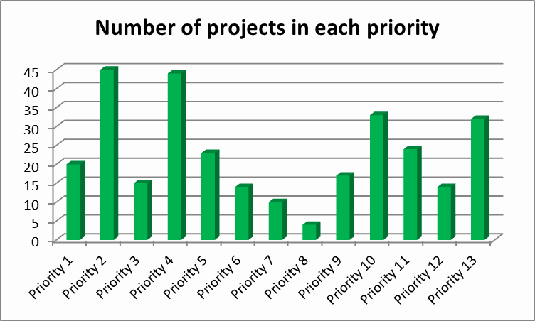
Figure 27 : Number of projects in each priority
According to this analysis the most developed priorities are priorities 4, 2, 10, and 13. And the least developed priority is number 8 “Mobilising water-related innovative financing solutions for the application of the Strategy”.
Moreover, one of the assessing criteria that define the Strategy is the geographical scope where the project would be developed. This is an important aspect as the objective of the 5+5 is the co-operation between its member states, the common work and the mutual support to face the shared water challenges. The added value of most of the projects is their possibility to be extrapolated to other parts of the Western Mediterranean.
According to their scope of application, the projects have been classified in three tiers: local, national and regional (where more than one country of the 5+5 is involved). According to this classification, the number of projects within each of the tiers is the following:
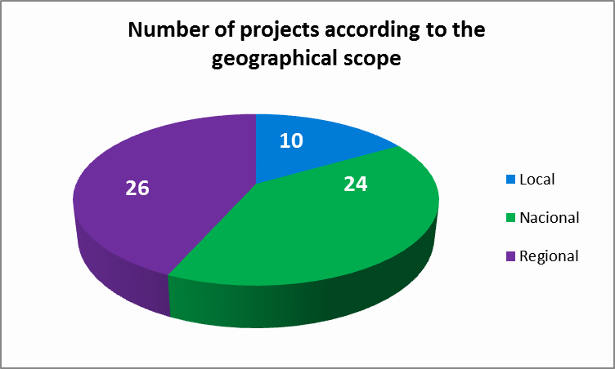
Figure 28 : Number of projects according to the geographical scope
The majority of the projects presented are not being developed at present although some of them belong to the second phase of others already completed as for example the SWIM (Sustainable Water Integrated Management Program) of the European Commission.
There are other projects that are already underway as for example the project promoted by the GWP-Med and the OECE (Governance and Financing for the Mediterranean Water Sector), the project presented by Spain (Special Plan for achieving the ecological potential of the RAMSAR wetland of the Albufera Lake), by Morocco (Promoting sanitation systems in rural areas, Implementation of a new law for the protection of aquatic areas) and by Malta (Production and distribution of highly polished treated effluent).
The rest of the projects have not yet started and are at different stages of preparation.
Regarding the budget of the projects the difference between them considerable and includes projects from 100.000€ to over 120€ millions. In addition, for the majority of projects financing has not been approved yet although many of them indicate possible subsidies and financing covered by the objectives of the Project.
In relation to the timeline for their implementation, there is a high degree of heterogeneity between the different projects as that ranges from some months to over 10 years.

Project proposed by Portugal
Some data on the projects proposed by Portugal are still pending.
Project proposed by Portugal.
The projects have been assigned to countries only where countries are the sole promoters. There are projects promoted by regional organisations which are also promoted by countries but these have been assigned to the regional organizations.
Portugal has presented an interesting compilation of projects in a number of the countries within the scope of 5+5 which are part of its strategy for the sector of water supply, sanitation and efficient use of water. These projects have already been assigned to Portuguese companies; yet, in the uncertainty about their compliance with the proposed criteria of the Strategy, for the time being it has been decided not to take them into account in the subsequent analysis, although they are indeed included in the annex of the description of the projects.

